**Manual for PamGuard Users on Distance Sampling Surveys**

**Coordinator: Angus Henderson**

The following document is a guide for setting up and using PamGuard for Polar Whale Watch Distance Sampling (DS) surveys. It contains pathways to be followed to start using the software, as well as to insert collected data in specific boxes, and to record files to be further analysed. Info associated with screens may help to answer several specific and common questions made by users. You’ll also find content on how to conduct DS survey data information.

# Contents

I. Contents 1

List of Figures 2

List of Tables 3

II. Setting up the gear 3

Laptop login 8

Start-up 8

Setting up GPS Data Collection. 13

Viewing the Data 15

Data Samples 17

III. Roles of Team onboard 18

When to work 18

Starting effort 19

Where to look? 21

IV. Collecting data: LOGGER FORMS 23

Overview 23

Entering Effort Data 23

Using PamGuard 25

Observing weather 27

Sightability 29

Sea State and Swell 31

Weather and cloud cover 32

Visibility and light levels 33

Glare and Ice 34

A few further notes on sighting marine mammals in different weather conditions. 35

Ice Guide 36

Sighting data 38

Making a sighting 38

Entering Sightings data 39

Recording Angle 40

Recording Distance 41

Identification of species 43

Aggregations 45

What is a group? 45

Determination of group size 45

When Busy 45

Marine debris 49

Resighting data 49

V. TIPS TO OPTIMISE THE DATA COLLECTION AT THE BRIDGE 51

## List of Figures

Figure 1. Location of observation platform 4

Figure 2. Example of how field gear is set up on the bridge of vessels (Hurtigruten, Nansen or Amundsen). Top left, position of the observer at the second window, top right observer in front of the second window and below the data logger on the computer. 5

Figure 3. Angleboard, suction cupped to the window 6

Figure 4. Angleboard placement on window 7

Figure 5. Locate desktop folder. 8

[Figure 6. Database file name location in PamGuard 9](https://universitytasmania-my.sharepoint.com/personal/angus_henderson_utas_edu_au/Documents/1%20-%20PhD/Field%20season/Documentation/PWW_5_Using_PamGuard_Manual.docx#_Toc150420211)

Figure 7. Creating a database file in PamGuard. 9

Figure 8. Selecting the database file in PamGuard, part 2 10

Figure 9. Selecting database file in PamGuard, part 3 10

Figure 10. Selecting database file in PamGuard, part4 11

Figure 11. Selecting database file in PamGuard, part 5 11

[Figure 12. Confirmation of database file selection 11](https://universitytasmania-my.sharepoint.com/personal/angus_henderson_utas_edu_au/Documents/1%20-%20PhD/Field%20season/Documentation/PWW_5_Using_PamGuard_Manual.docx#_Toc150420217)

Figure 13. Editing a list in PamGuard, entering observer names. 12

Figure 14. Editing a list in PamGuard, entering observer names, part 2 12

Figure 15. Map of ships track. 13

Figure 16. Selecting GPS/NEMA feed. 14

Figure 17. Database file location 15

Figure 18. Viewing the database file in 'DB Brower' 15

Figure 19. Browse the data that has been collected 16

Figure 20. Database copies. 17

Figure 21. Database file location 17

Figure 22. Diagram of whale observation process 20

[Figure 23. Examples of observation focus area 21](https://universitytasmania-my.sharepoint.com/personal/angus_henderson_utas_edu_au/Documents/1%20-%20PhD/Field%20season/Documentation/PWW_5_Using_PamGuard_Manual.docx#_Toc150420228)

Figure 24. Example diagram of where most whale sightings are made. 22

Figure 25. Saving PamGuard Effort form. 25

Figure 26. Editing data after it has been saved. 26

Figure 27. Editing data after it has been saved, part 2. 26

Figure 28. Environment tab 28

Figure 29. Sea state 31

Figure 30. Swell 31

Figure 31. Weather 32

Figure 32. Visibility 33

Figure 33. Light Levels 33

Figure 34. Glare 34

Figure 35. Ice Cover 34

Figure 36. Ice type 35

Figure 37. Sightings Form 38

Figure 38. Entering Platform data. 39

Figure 39. Sighting Cue 39

Figure 40. Angleboard 40

Figure 41. Measuring reticles, here reticles = 5. 41

Figure 42. Type of distance 42

Figure 43. Selecting Species 44

Figure 44. Group Behaviour 46

Figure 45. Pod compaction 47

Figure 46. Photos Taken 47

Figure 47. Saving the Sighting form 48

Figure 48. Editing past sightings 48

Figure 49. Resighting form, matching to the sighting number 49

Figure 50. Resighting confidence 50

Figure 51. Readout of ship information, true wind, GPS etc. 51

## List of Tables

Table 1. Summary of role of the Observer and Datalogger 19

Table 2. Overview of logger forms 23

Table 3. Whale observing activities description. 23

Table 4. Defining appropriate weather conditions. 27

Table 5. Sightability scale 30

# Setting up the gear

We set up where the drawing shows (red circle):

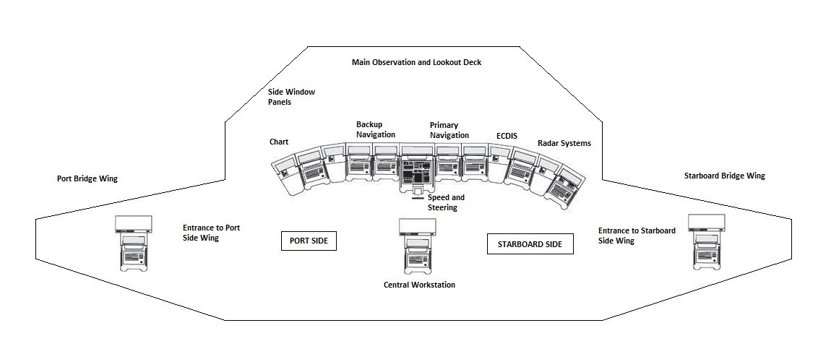

Figure 1. Location of observation platform

This differs per vessel, for HG MS Nansen and MS Amundsen, here are examples.

From the main windows of the front of the Bridge we are on port side on the windows that are angled exactly 20 degrees from heading of the vessel straight ahead. The angle boards can be adjusted to suit.

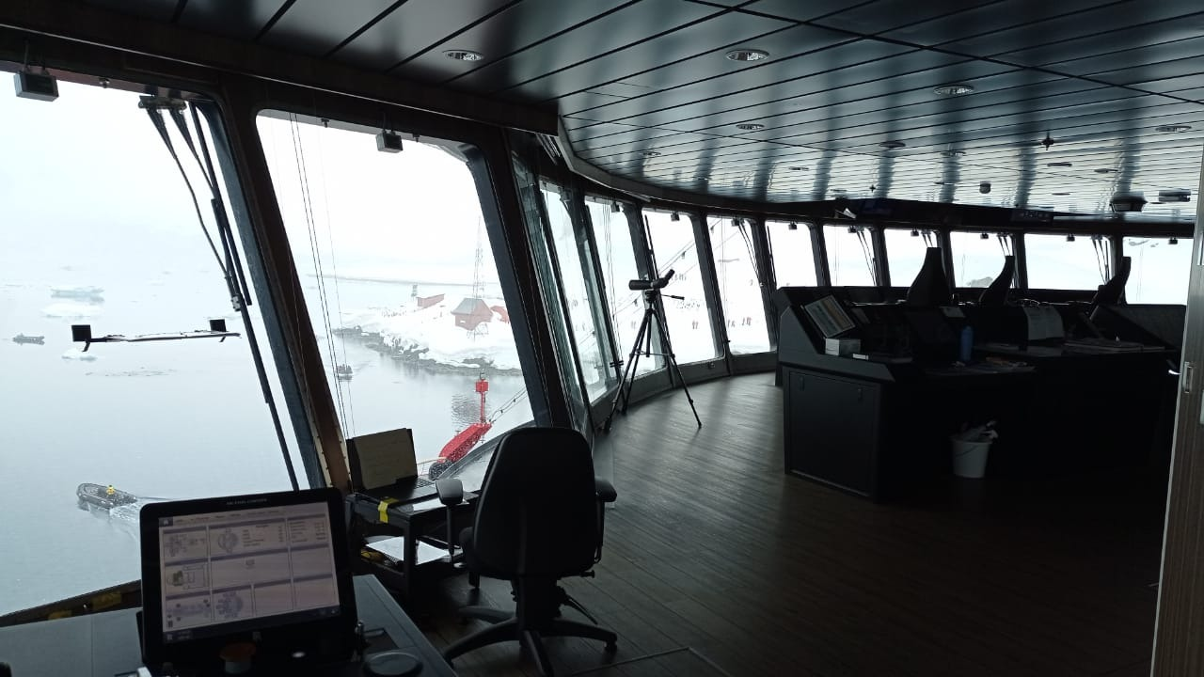

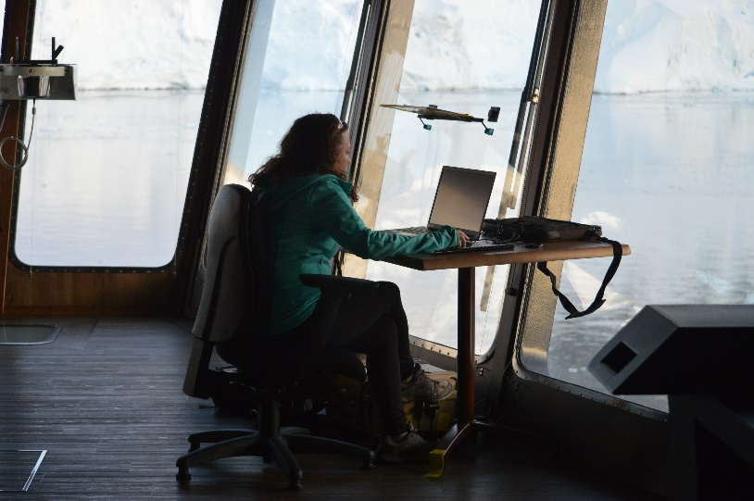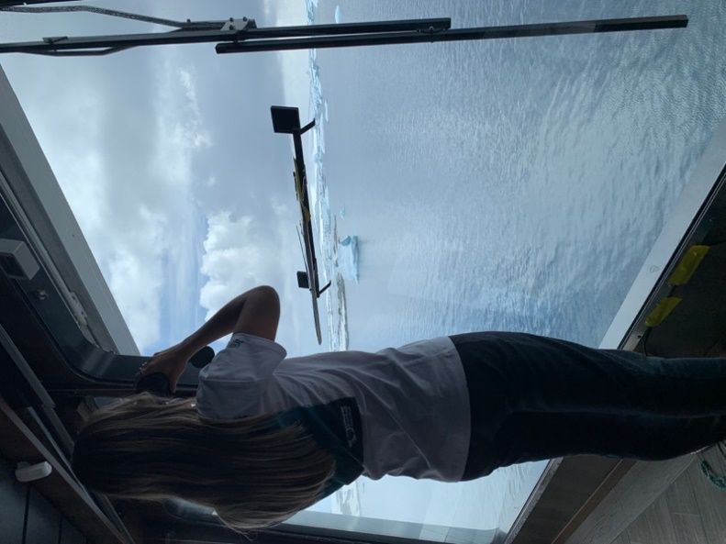

Figure 2. Example of how field gear is set up on the bridge of vessels (Hurtigruten, Nansen or Amundsen). Top left, position of the observer at the second window, top right observer in front of the second window and below the data logger on the computer.

The computer is on a small table with the binoculars, books, Beaufort chart etc in the first angled window, to the right of the Angleboard. Computer is plugged to the plug in the floor with the adaptor, GPS plugged to USB port on computer, all taped to the floor/window accordingly. Computer taped to the table too. No room for mouse. They gave us a chair for the datalogger. Make sure tip hazards are removed.

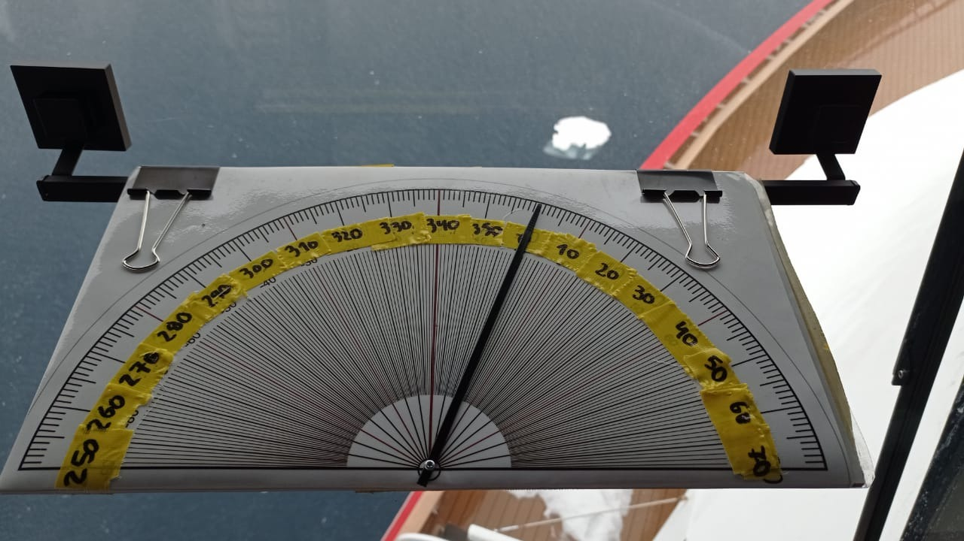

Figure 3. Angleboard, suction cupped to the window

The exact measurements of the Angleboard location are here, it is important to follow these measures for standardization across seasons.

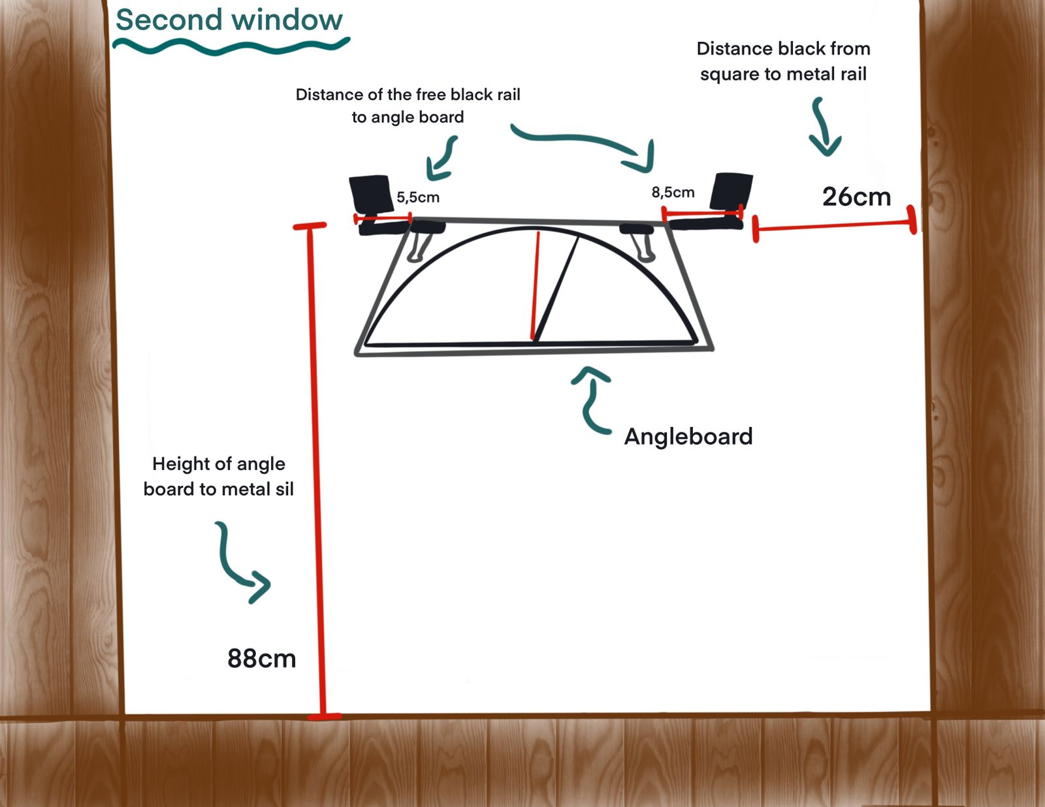

Figure 4. Angleboard placement on window

For alternate vessels a document will be provided.

## Laptop login

Below you will find the login and passwords for all laptops to be used by this project.

Laptop: Whale01 User: WhaleCounting01 Password: Whale01. Pin: 0101

Laptop: Whale02 User: WhaleCounting02 Password: Whale02. Pin: 0101

Laptop: Whale 03 Username: .\whale01 Password: WhaleCounting01

PamGuard.

PamGuard is an interface that aids data input, as well as recording GPS data in the background. The “.psfx” file described later is the configuration file, and the “.sqlite3” file is the database where the data is held. Every time you ‘save’ a form this enters this line of data into the “.sqlite3” database file.

## Start-up

**Step 1** - Turn on the laptop, Find folder on desktop. “PWW_PG_2023_24”, and double click, “PWW_CONFIG_v1”. This will open PamGuard.

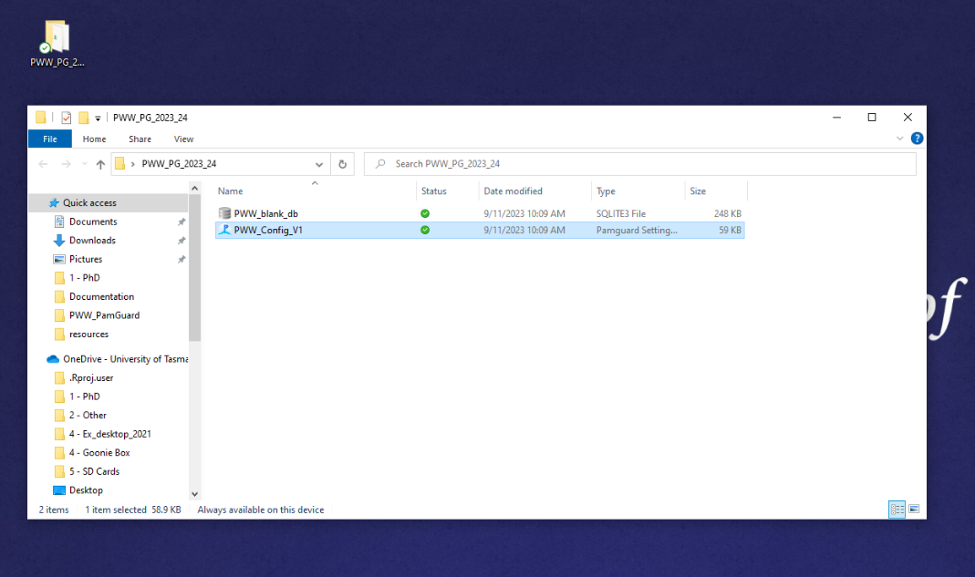

Figure 5. Locate desktop folder.

**Step 2 –** PamGuard is now open, locate the database it is connected to - See below ‘here’. If this box is grey and the correct database for your trip is selected skip to **step 7-Entering your names**. If this is not the correct database or the box is red will need to create a new one (**step3**)

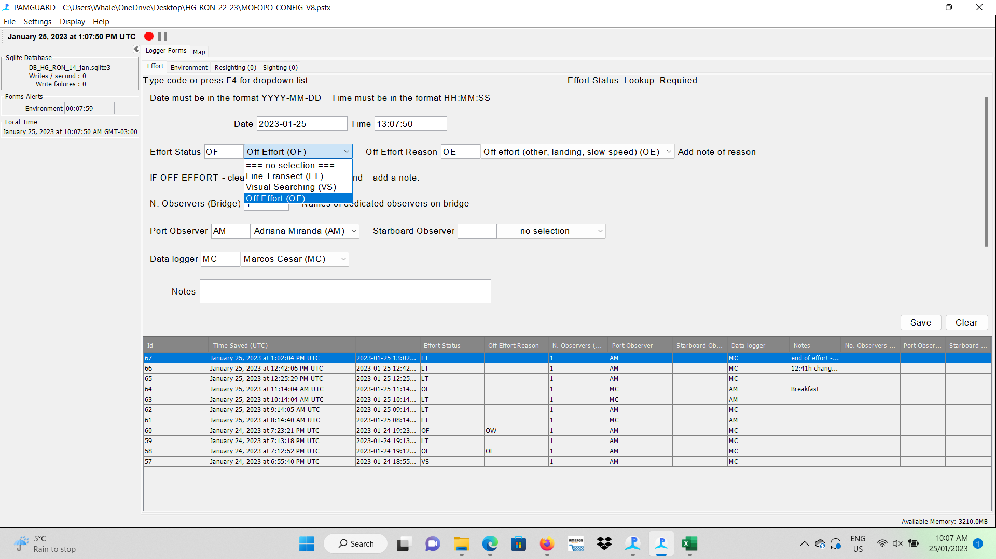

Figure . Database file name location in PamGuard

Here

**Step 3** – Create a database for your trip, go File >Database >Database Selection > Browse/Create…

Create a new database for each trip

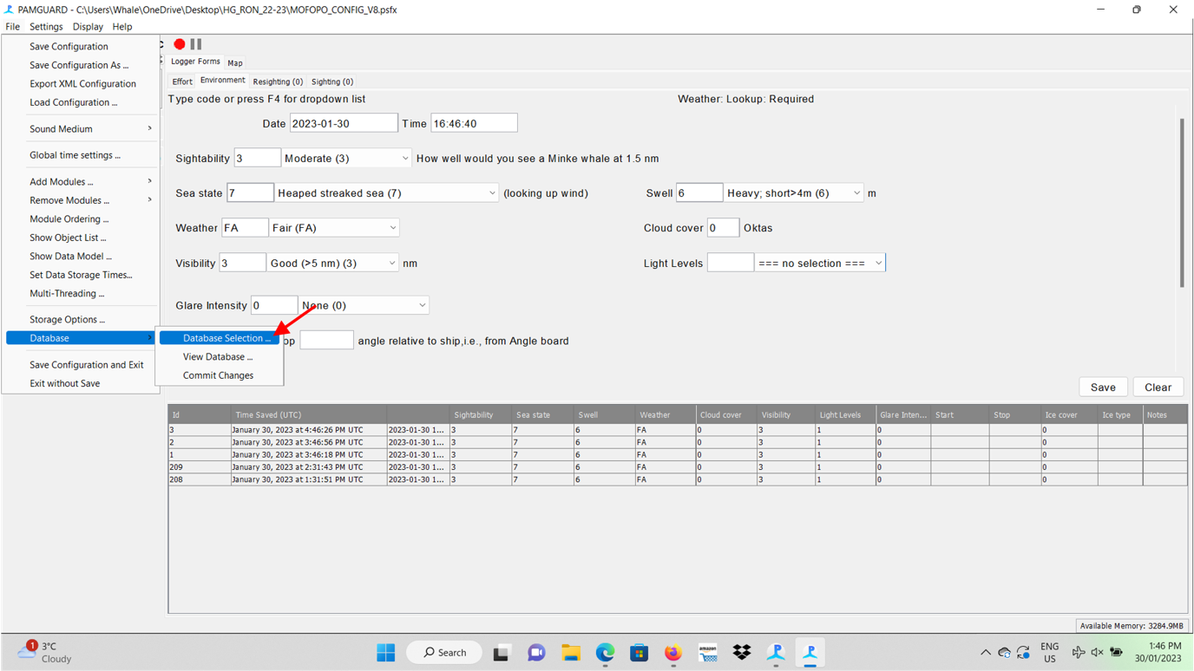

Figure 7. Creating a database file in PamGuard.

**Step 4** – Browse in computer for the folder – (red arrow indicating)

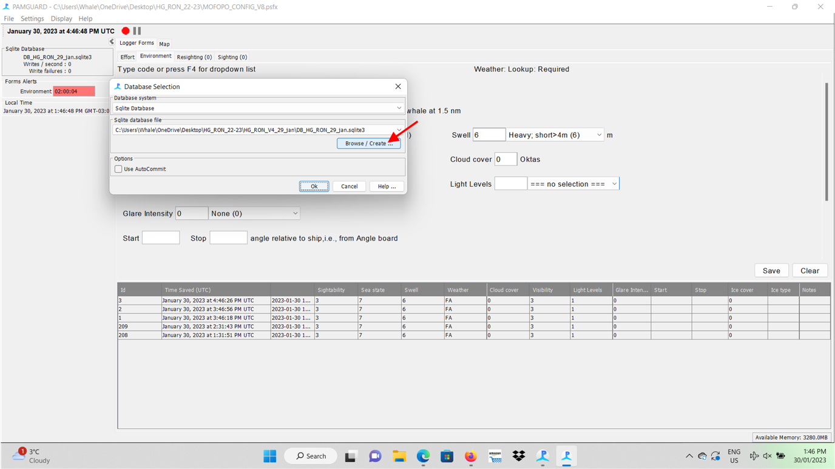

Figure 8. Selecting the database file in PamGuard, part 2

**Step 5** – Follow the file Desktop -> PWW_PG_2023_24->HG_NAN->HG_NAN_13_Nov-> and create a new database, following “DB _NAN_nov_13” (DB_ and shortened versions of company_ship_month_departure date). and save (red arrow indicating).

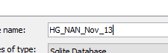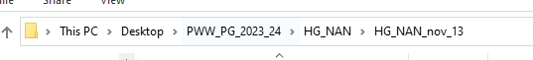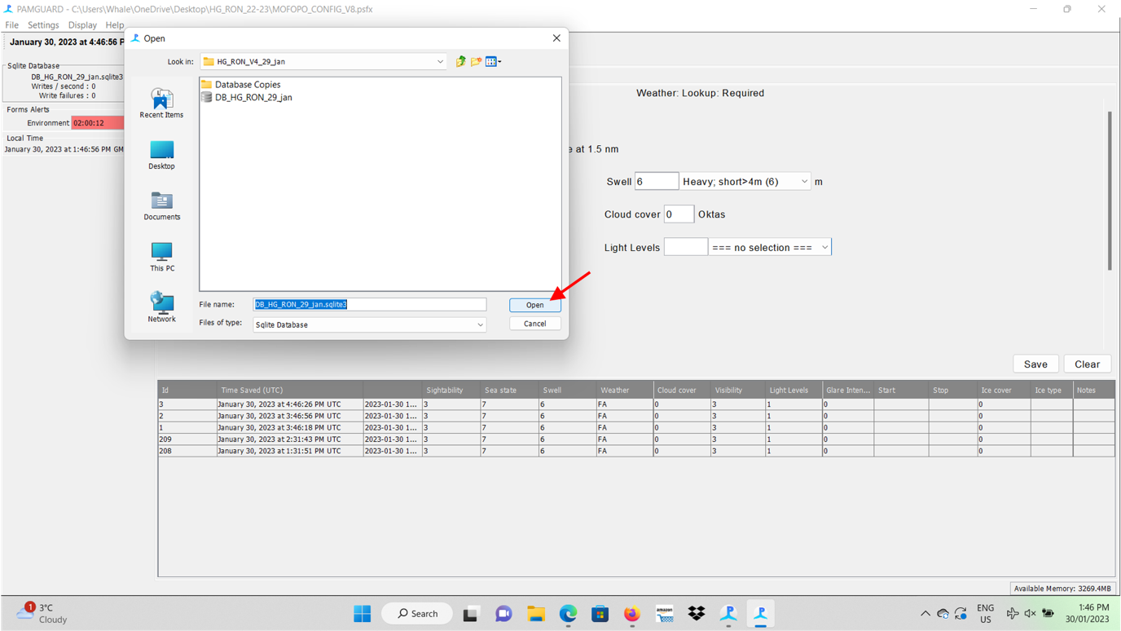

Figure 9. Selecting database file in PamGuard, part 3

**Step 6 – press ok**

Press ok to creating a new database file.

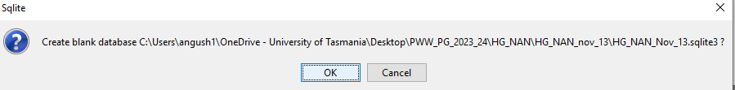

Figure 10. Selecting database file in PamGuard, part4

**If you get this message, Press Cancel!**

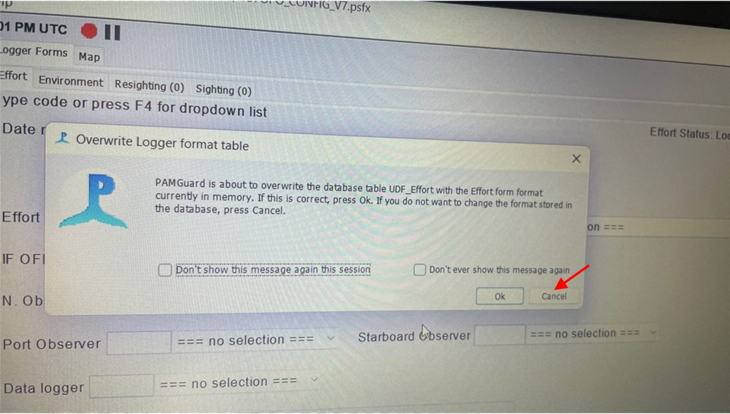

Figure 11. Selecting database file in PamGuard, part 5

**Step 6 – Save and exit.**

Now go File > Save Configuration and Exit.

And reopen PamGuard.

You should see the ‘effort’ form, and tabs for ‘environment’, ‘resighting’, & ‘sighting’. If not go Settings > Logger Forms > Regenerate all forms, and they should pop up.



If this is red not grey there is an issue.

If any of this doesn’t work contact Angus

Figure . Confirmation of database file selection

**Step 7 - Enter your names in the system as observers if not already done.**

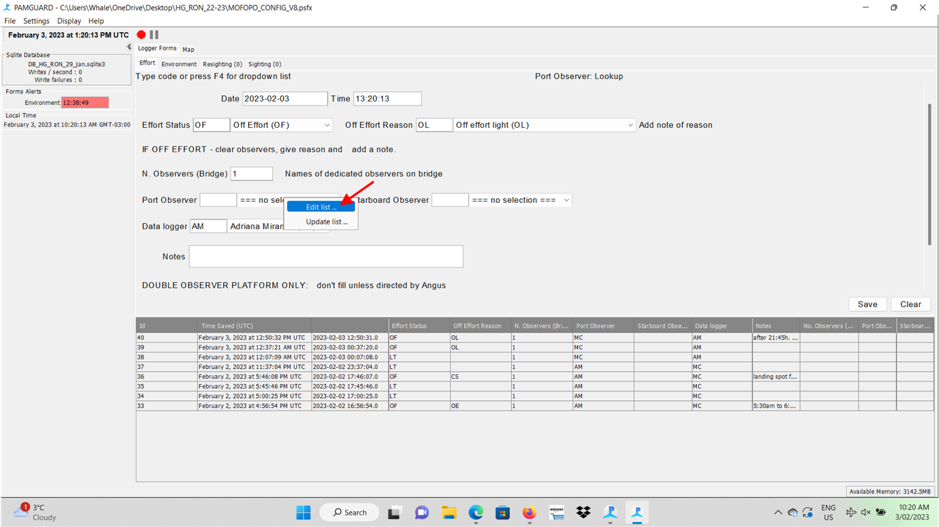

Figure 13. Editing a list in PamGuard, entering observer names.

After inserting the names of all researchers, these data will be available as options to be chosen as “observer(s)” (star and/or port board) and “data logger” as follows:

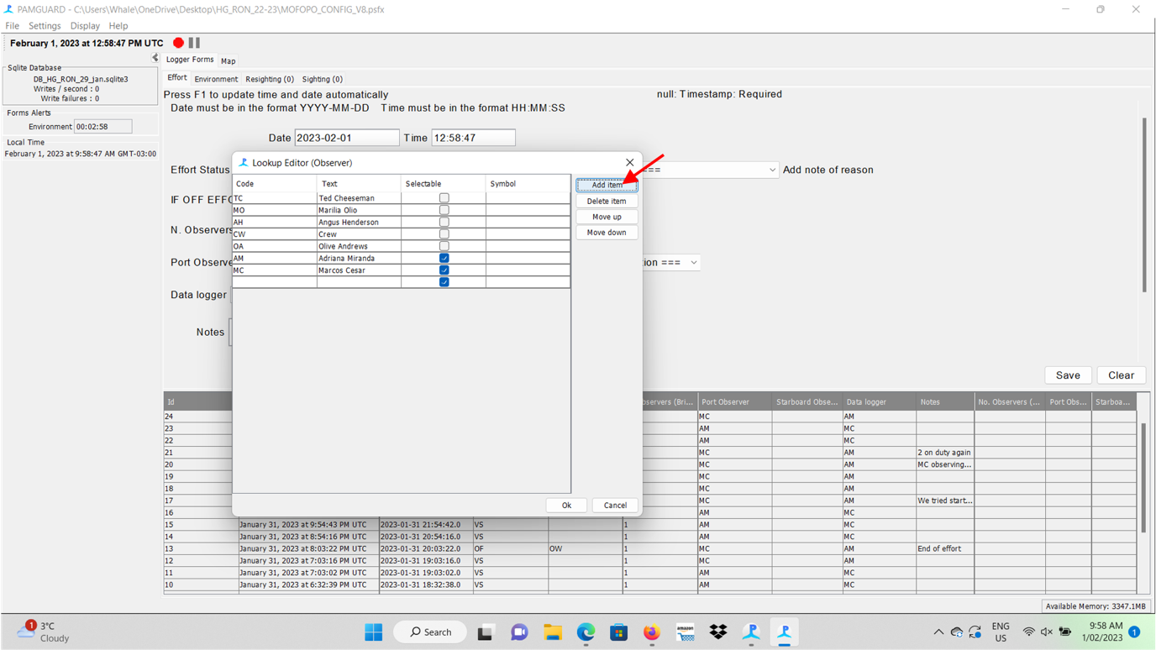

Figure 14. Editing a list in PamGuard, entering observer names, part 2

## Setting up GPS Data Collection.

**GPS/NMEA feed – very important!**

**This is one of the trickier steps, and critical to get working. The map needs to be checked to make sure the GPS is precisely collecting the coordinates** – When clicking on the map tab, you will have access to the precise lat/long data (red arrow indicating) that must be synchronized to the same data of the ship/vessel GPS (ask bridge crew) and/or a manual GPS if you had taken one on board.

The location panel in the bottom right of the map should be grey if working and red if not.

Whenever data logger is on, their task is to regularly check if the GPS is grey (working) and matches the ships GPS.

Sometime parts of the track will be missing from the map, this is not a problem as long as this box is grey when recording data.

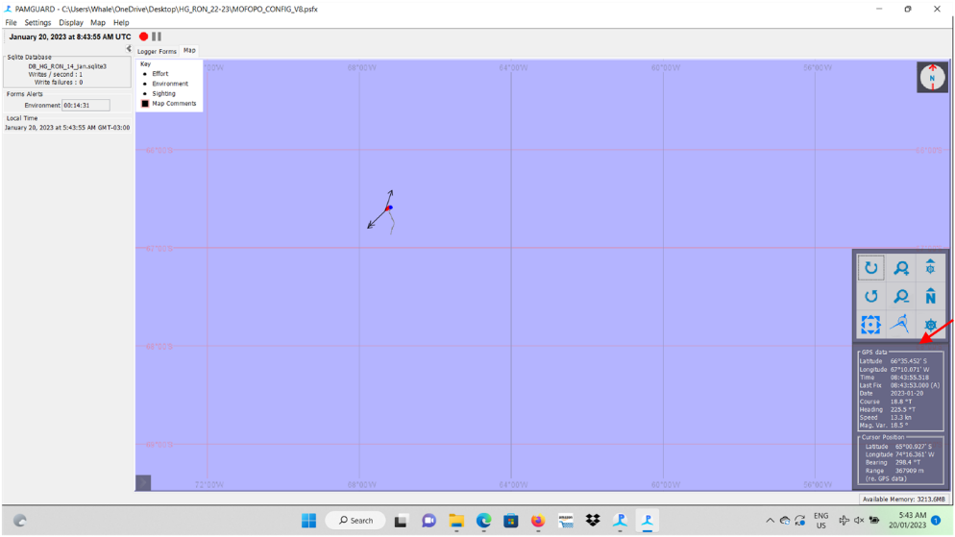

Figure 15. Map of ships track. (red box highlights the working GPS - grey fill)

If the GPS is not working try (RED), open Settings >NMEA Data Collection > NMEA Parameters > Serial NMEA data. (red arrow indicating)

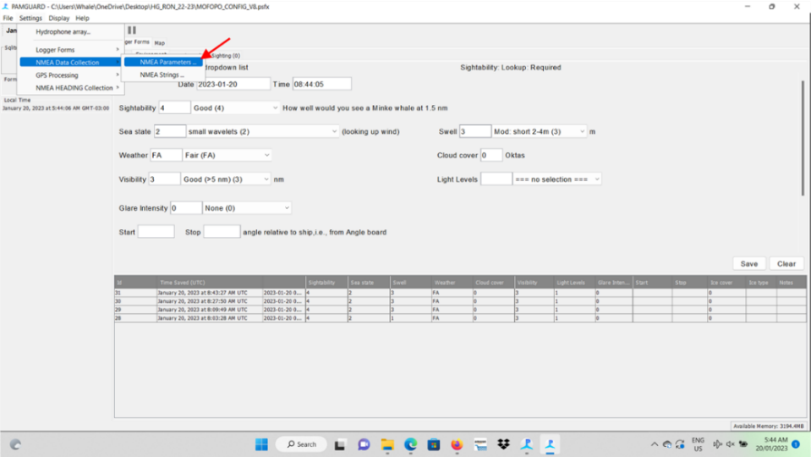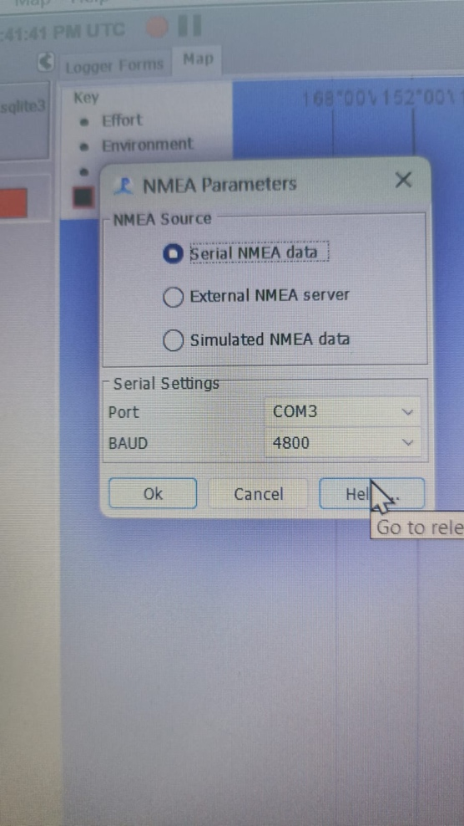

**this should come up, click ok. ->**

Figure 16. Selecting GPS/NEMA feed.

* If still red (not working), try waiting.
* If still red (not working), try Settings >NMEA Data Collection > NMEA strings. If there is something in this box, then it might be lack of reception. In this case, move the GPS unit around for a better signal or try taking the laptop attached to the GPS outdoors in order to get a better satellite connection. Possibly, after synchronized with satellites, it will work perfectly inside the bridge. Also, try to attach the GPS at the window of the bridge to better reach satellite signals.
* If still red (not working) and there is nothing in the strings box, try Settings > NMEA Data Collection > NMEA Parameters again, and change the Baud rate to **115200 or 4800** depending what its on.
* If still nothing, contact Angus.

Once everything is set up and working.

**PLEASE leave the laptop, GPS and PamGuard on and running at all times.**

**When done for the day, pack up all the gear, turn the brightness on the laptop screen and leave everything in place. Unless instructed by the captain to do otherwise.**

## Viewing the Data

All the data is entered into the PamGuard is held in a the database file. The database file can be checked by double clicking/opening its folder in the DB Browser (red arrow indicating). It will open in DB Browser – do not edit this data, or save when closing.

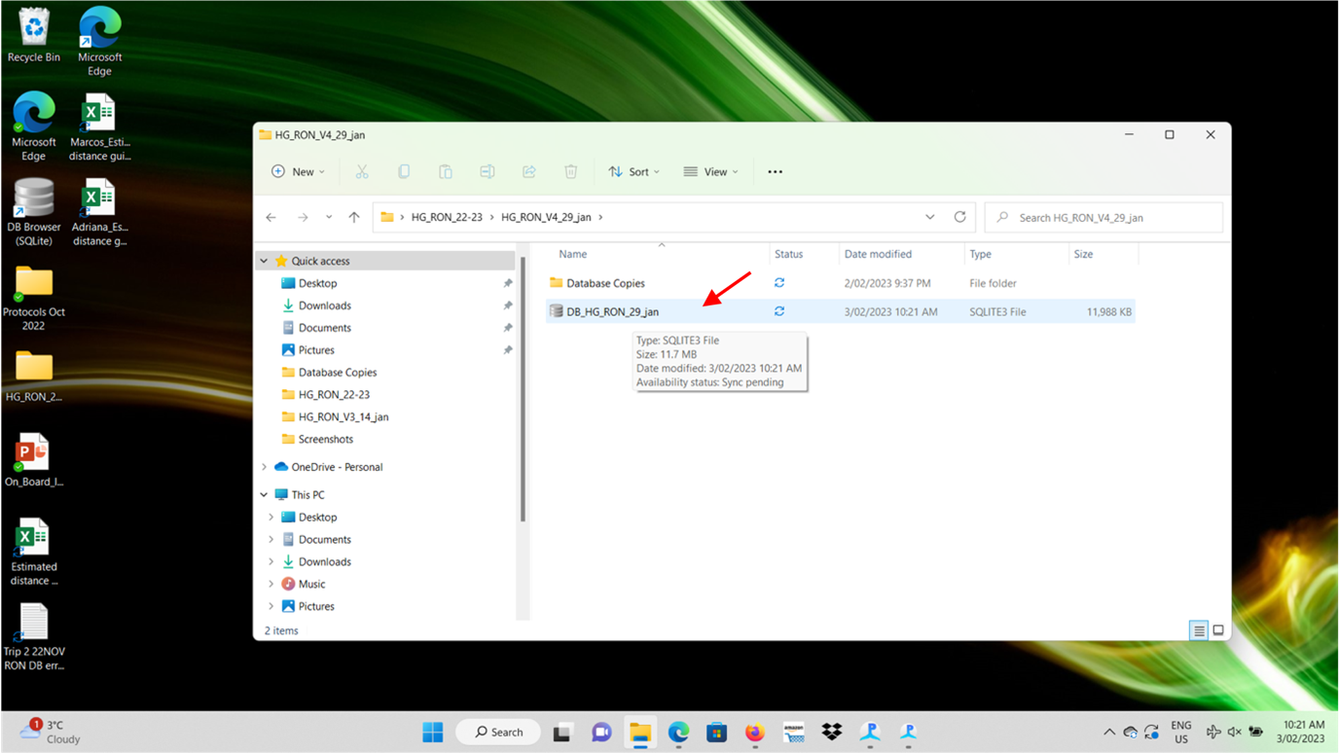

Figure 17. Database file location

**DB Browser view**

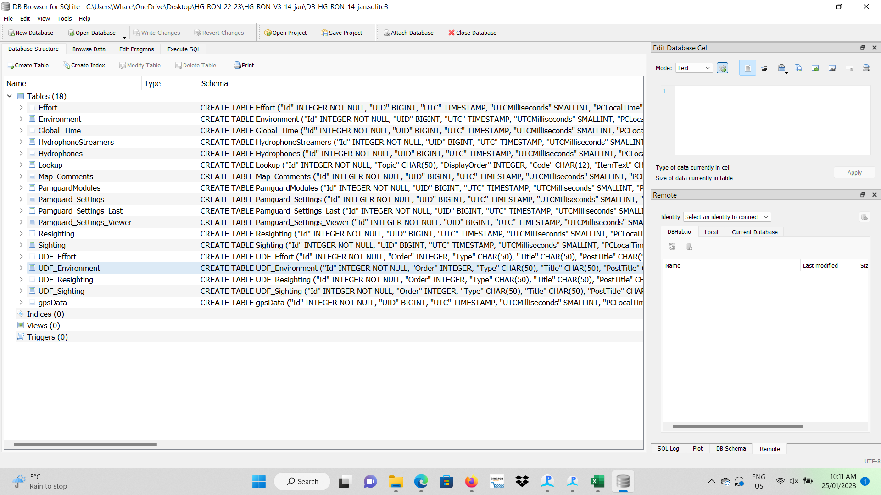

Figure 18. Viewing the database file in 'DB Brower'

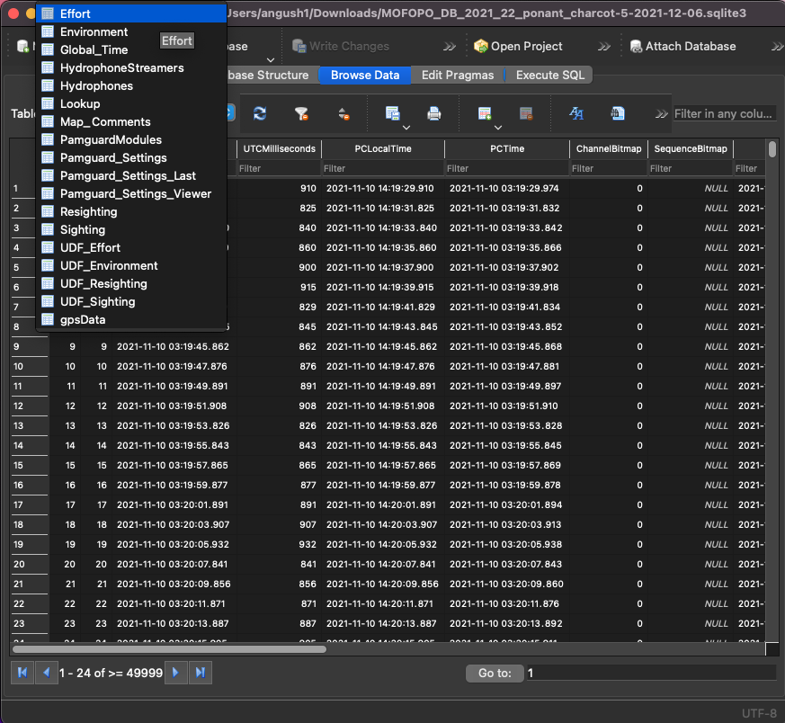

Figure 19. Browse the data that has been collected

Here you are able to browse data collected. For example check the effort data you have entered (or Environment, Sightings, Resighting). Can also see here if the Gpsdata has been entering into the database in the background.

Don’t edit this file or save changes.

## Data Samples

**Across the first few days, a copy of the database must be sent to the coordinator to make sure everything is working correctly. To do this make a copy of the database file, paste and rename it with V (from Version) and the sample number (e.g., V1 for the first sample).**

Email: angus.henderson@utas.edu.au

Go to the desktop, find the DB Browser (SQLite), click on it, and the window you’ll find below will open:

Copy the database file, past and rename it with V (from “Version number”) and the sample number (e.g., V1 for the first sample - red arrow indicating).

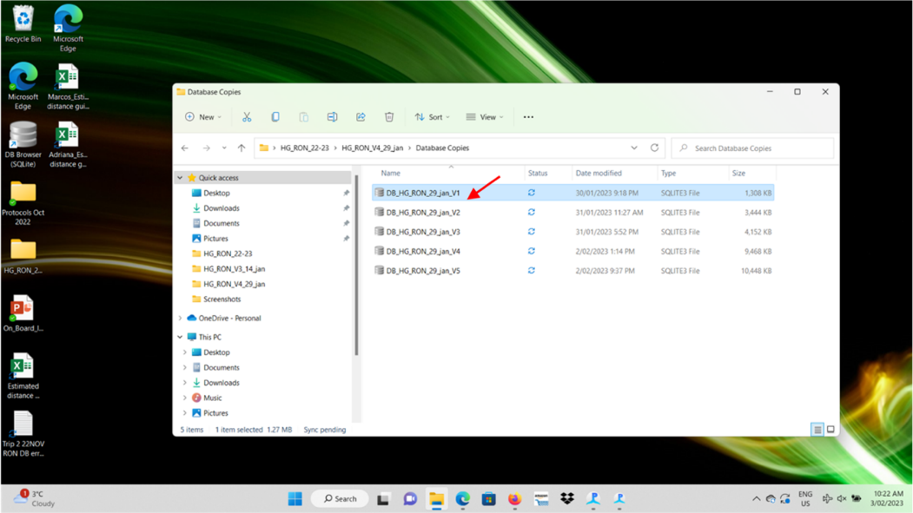

Figure 20. Database copies.

**Do not change the original database file (e.g., below) only make a copy and change the copy.**

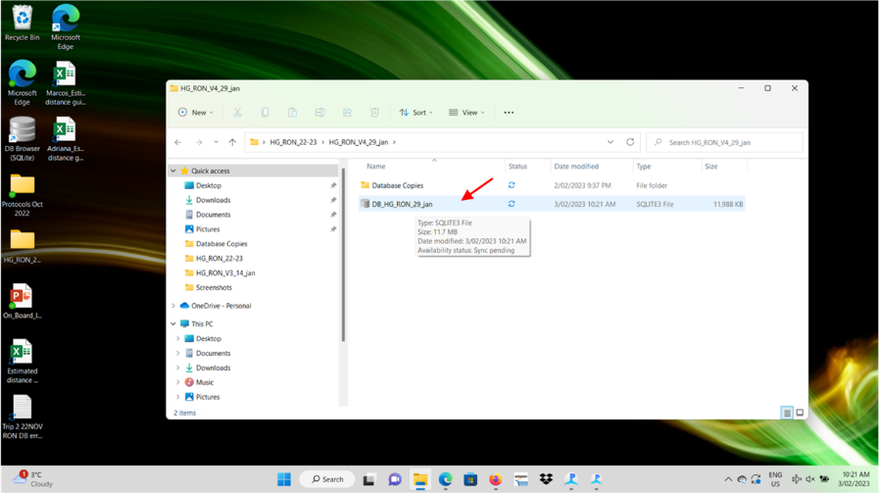

Figure 21. Database file location

**At the end of the voyage** make a copy of the DB database file add “_final” at the end and send to Angus with the voyage report. angus.henderson@utas.edu.au

# Roles of Team onboard

## When to work

This will vary across the season and is based on ship movements, weather and light conditions, and observer availability. Work from the first day of the voyage to the last day. For multiple consecutive voyages, from the night before you arrive back in Ushuaia until the first morning at sea, you are not required to work. This should give you 36 hours or so off before recommencing. Get some rest.

Generally, a working day consists of:

* Getting up early and getting 2-3 hours of observations before breakfast 4/5-7/8am. Weather and light dependent.
* Most days (except the crossings) there will be attempted landings after breakfast (no observations when the ship is stopped). Can be a good chance to rest.
* Then the ship will then move to another location. Take observations then.
* Most days (except the crossings) there will be attempted landings after lunch (no observations when the ship is stopped). Can be a good chance to rest.
* Often the ship stays at anchor during dinner. But if not before dinner can be a good opportunity to collect data.
* After dinner there is rarely an opportunity to collect quality data. Best to save yourself for early mornings.

Crossings will generally be long days, but are great data, work to maximise weather and light conditions. You will get a chance to rest when the ship does landings.

Generally light conditions dictate, starting 1-2 hours after sunrise, and finishing about 1-2 hours before sunset.

Breakfast is at approximately at 7, lunch at 12/1230, and dinner at 18/19. Make sure you stop and eat.

**The bridge staff will give an idea of the ship’s logistics, but these can change. It is best to get up to the bridge and check conditions and ship movements directly.**

There will be plenty of opportunities to do all the activities onboard; so relax! Your time will come.

## Starting effort

When weather and light levels allow, a single observer will undertake full search effort (i.e., **Effort = Line-Transect**) from the Bridge. A data logger will be in position, near the observer. The observer and datalogger will communicate directly, as they will remain in close proximity.

**All observations are to be taken by the observer with no outside interference by the crew, datalogger, or other staff. However, once the species is sighted, help with species identification, etc is advised.** If someone else make observations that the Observer misses (given the chance), these can be entered as **Incidentals (IS)** once they have passed out of the 0-90 observation quadrant and a note added confirm that it was missed by observer.

When conducting observations, marine mammal observers rotate through two watch positions: 1) observer, and 2) datalogger, typically shifting positions every 45-75 minutes.

A typical working day may consist of several 2-4 hours sessions with breaks and lunch in between. It's critical to take adequate breaks and manage your fatigue to make consistent quality observational efforts. **So that 1 hour of *Line-Transect* effort in the morning of day 1 is equivalent to 1 hour of *Line-Transect* effort in the evening of day 20.** Once weather conditions exceed Beaufort 6 (inclusive), observers will go **Off-effort**(i.e., **Effort = Off-Effort** Weather) and the scheduled data logger will only record weather every hour (when possible). There is no need to return to the ship every hour during landings.

Table 1. Summary of role of the Observer and Datalogger

|  |  |
| --- | --- |
|  | Role and tasks |
| **Observers** | To observe and relay the sighting, environmental information to the datalogger. Does not enter data into the form while observing.  **All observations are to be taken by the Observer with no outside interference by the crew, datalogger, or other staff.** |
| **Datalogger** | Prompts observer for information to log into PamGuard forms.  Records weather every 15-minutes  May aid in species ID  If sightings are made by someone other than the Observer, log the sighting as **Incidentals (IS)** once the whale/dolphin have passed out of the 0-90 observation quadrant  Photos to be taken by the datalogger only. |

When you get a sighting, **no matter how busy, get sighting cue, angle, reticule, species and some idea on number of animals**. Anything extra is a bonus. **Take your time** with the sighting, they will probably surface again, and stay with the group (if still at the surface) until you get all the fields filled out. Then move on to other groups. **It is best to try and complete the sighting (with minimum data – angle, reticule, group size, species) before moving on**.

Its most important to get the closer, and within 30-45 degrees of track line (see below ‘where to look’) sightings correct first before moving on to further away ones.

Note that sightings that are ahead are likely to pass quite close, so noting angle, reticule, group size and cue, then leaving them to come towards you to complete that sighting can be a useful method. After some time, you will begin to get a feel for the vessel speed and understand how quickly sightings reach you, tracking and mentally noting them as they move through your sighting zone.

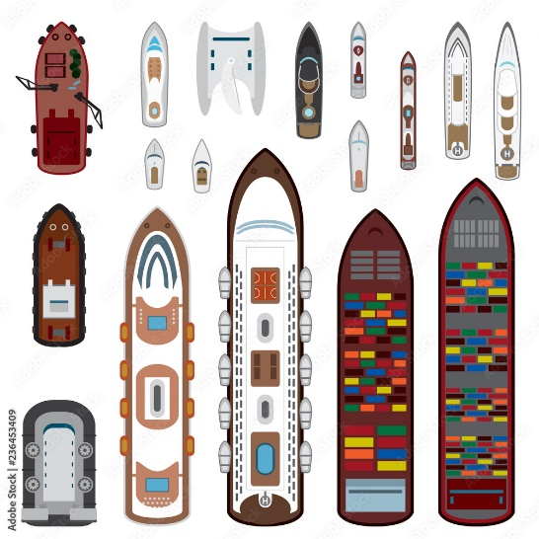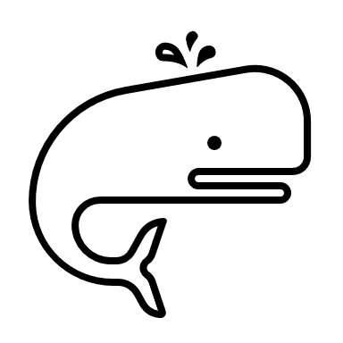

Angle ~311

Ships track, and direction of movement.

If the whale is close to the ships track, as the ship moves forward, the whale will shift towards the observer.

Ship

observer

Figure 22. Diagram of whale observation process

## Where to look?

During **Line-Transect** searching, the observers on watch will actively scan the port forward quarter (from starboard/port beam (90/270°) through to straight ahead (360°) making for a 90° search region) for new sightings, **with particular focus on the track line ahead of the vessel (e.g., 30-45 degrees either side of straight ahead - 360˚)**. Observers are instructed to scan their entire area of responsibility in a consistent manner and not focus on particular regions (but spend a little more time scanning forward along the track than closer to abeam).

The majority of focus in this red area, or the front facing 30-45 degrees (or so). Red circle is observation position.

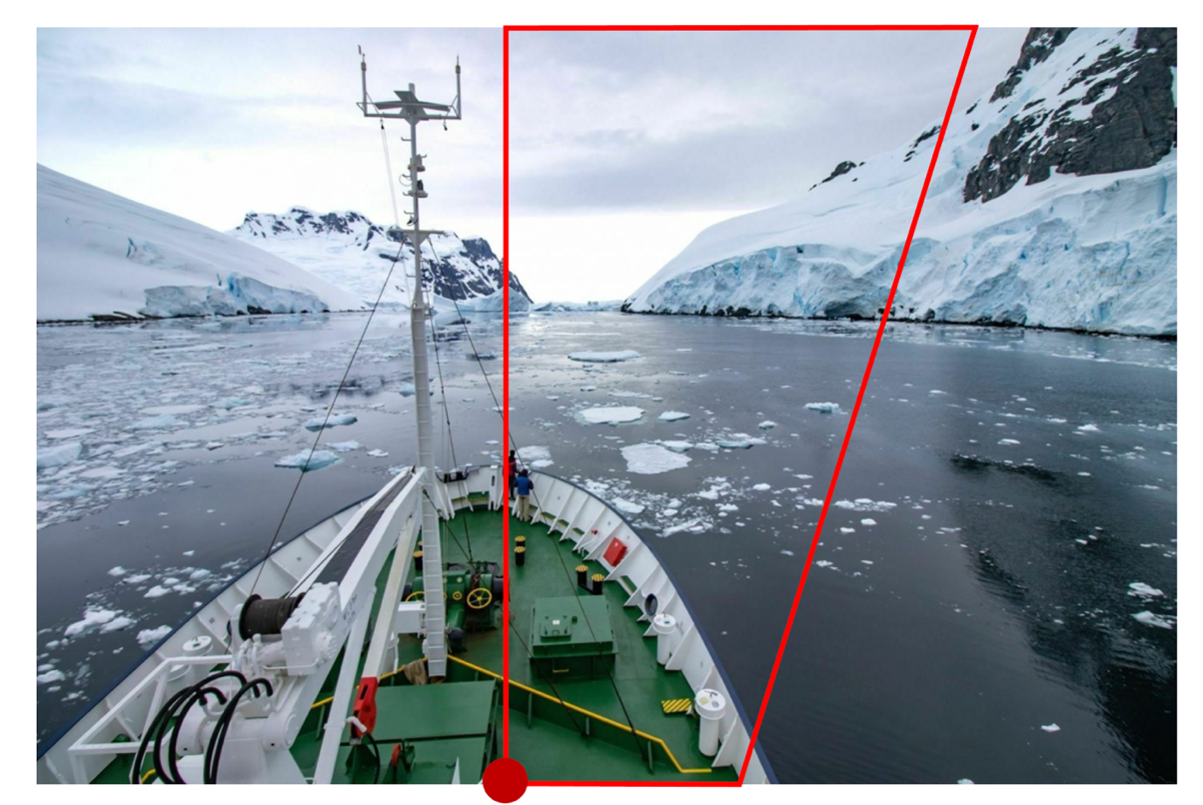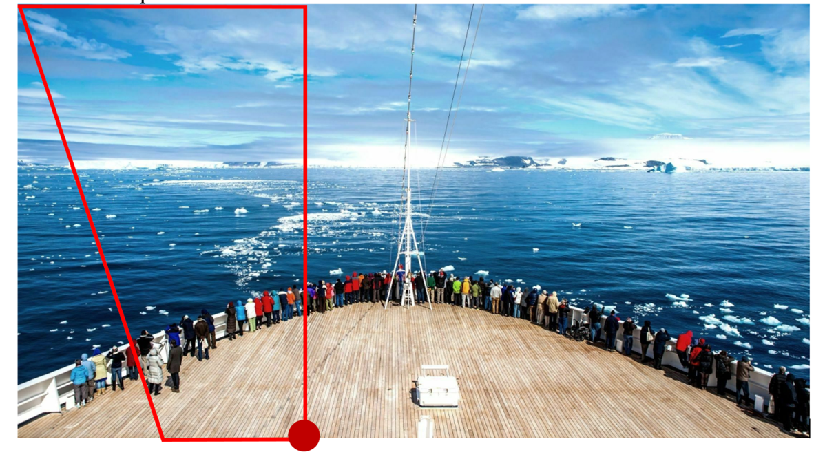

Figure . Examples of observation focus area

**Observers will predominantly use naked-eye (90% of the time) and the 7 x 50 binoculars (10% of the time) for searching**. All distance measurements are to be made with the reticle binoculars where possible (exceptions include, when sightings are too close). During search mode (i.e., **Line Transect**), sightings data are collected only by the observer on watch. **No information** from other MMOs, crew, guests about actual or potential sightings forward of 90° abeam is relayed to the primary observer.

The **Line-Transect** observers may be informed of missed sightings by other personnel once they are past 90° abeam, at which time they are entered as **Incidental Sightings (IS)** – see sightings form to log this.

If we calculated where all the sightings were made and plotted them together, we would expect something like this.

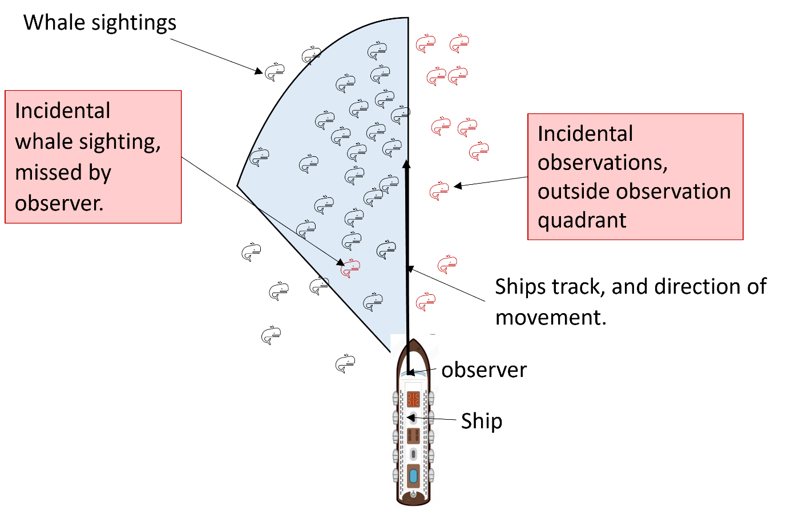

Figure 24. Example diagram of where most whale sightings are made.

# Collecting data: LOGGER FORMS

## Overview

**When you are all set up and ready to collect data, you need to consider the 4 logger forms,**

1. **Effort –** who is doing what?
2. **Environment** – under what environmental/weather conditions?
3. **Sightings -** what you saw?
4. **Re-sightings –** did you see it againwhat you saw?

Table 2. Overview of logger forms

|  |  |
| --- | --- |
| *Effort* | Should be updated every time the effort changes, (e.g., on effort to off effort, or change in observers). The most recent saved form is the current effort type. |
| *Environment* | On effort: every 15 minutes when **On Effort** (the form alert will remind you – on the left).  Off effort within the 12-hour working window, this should be every hour – if possible. |
| *Sighting* | To log a sighting double click the **Sighting** tab title. This will open a sighting and log the time stamp.  You can have more than one open at a time, however, try to save them as they pass the beam or are complete.  You can reopen them if you need, they remain as a data line in the bottom half of the sighting form. There is a data-line for each sighting which is also good to check, to make sure you have filled in all the fields.  You can access data you have logged again by clicking on it below the logger form. Try not to edit logged data, rather add info if it becomes available. The possible exception is upgrading the species identification on a sighting if you get a final resight. |
| *Resighting* | Very similar to sightings, used rarely (e.g., when marine debris is sighted), further discussed below. |

## Entering Effort Data

Here you will insert the baseline info on efforts when searching for cetaceans. It includes the type of searching (**Line Transect** or **Visual Searching**), or if you were **Off Effort** for any reason that should be indicated. Researchers’ names and roles should be inserted whenever they are fully engaged in one duty.

Make notes in the notes sections for me if you are unsure or there is complication

Effort Status: 3 options – **Line Transect**, **Visual Searching** and **Off Effort**.

Table 3. Whale observing activities description.

|  |  |
| --- | --- |
| Effort Status | |
| ***Line-Transect- Effort*** | BR-bridge sightings |
|  | activities are times when full search effort is being executed and conditions (such as weather and sea conditions) are within acceptable parameters, if weather is not acceptable go to **Visual Searching** or **Off effort.** |
| ***Weather*** conditions | Visibility: to be able to detect a strong minke whale blow (or other sighting cues) at a distance of at least 1.5 nautical miles (2.9kms), and  _True wind: speed less than 25 knots (in the vicinity of the ice edge) and  20 knots (remote from the ice edge), and  _Beaufort Sea state 6 (inclusive) or less.  *Note that these are maximum limits and calmer conditions within these limits may still not be appropriate for ***Line-Transect*** surveys. |
| ***Visual Searching*** | BR-bridge sightings |
|  | This is for times when full search effort is executed but conditions make it inappropriate for ***Line-Transect***. Please not as to why.  These include:   * Weather is not good enough for ***Line-Transect****,* but may clear shortly, and you are still on the bridge, maintaining active searching effort. * Icebreaking – moving at <5 knots and/or ramming ice by moving backward and forward. * Changing direction regularly, e.g., moving around ice floes or land masses. * Only a single observer team is available (e.g., due to seasickness) |
| **Off-effort** | **IS-incidental** |
|  | Completely in poor weather even if remaining on the bridge. |
|  | _when stopping (<6 knots), or  _stopped (e.g., landing anchoring), or  _in poor weather.  Note you may remain in these effort types for any length of time |
|  | If the vessel breaks away from the course to close in on wildlife, you are **Off-effort**. Any sighting not yet observed will be **IS-incidental,** details can be added to previous sightings.  Allow some time to clear this wildlife interaction before restarting the effort to ensure you are not double counting |
| **IS- Incidental sightings** |  |
|  | _If Sightings is Off effort.  _If Sightings are LT or VS - BUT you see an animal outside the observation quadrant.  _If someone else make observations that the Observer misses (given the chance), these can be entered as **Incidentals (IS)** once they have passed out of the 0-90 observation quadrant. |
| **Re-sight** |  |
|  | **If an animals seen outside the observation quadrant that then move into the quadrant.**   * If you see an animal outside the observation quadrant log it as **Incidental (IS)**. * If it then moves into the observation quadrant, log it as a **Resight.** * You can link the sightings in this way. |

### Using PamGuard

In PamGuard, when changing to **Off Effort**, the reason should be mentioned. Options are related to poor light conditions, reaching a spot to land guests, ship in slow speed (< 5 knots), or just closing sighting efforts.

Add the name of the observer and datalogger, and number of observers on the bridge (generally one).

Set the mouse on the names of the observers or the data logger and click with the right bottom to open the options to edit/update the list of researchers (see ahead).

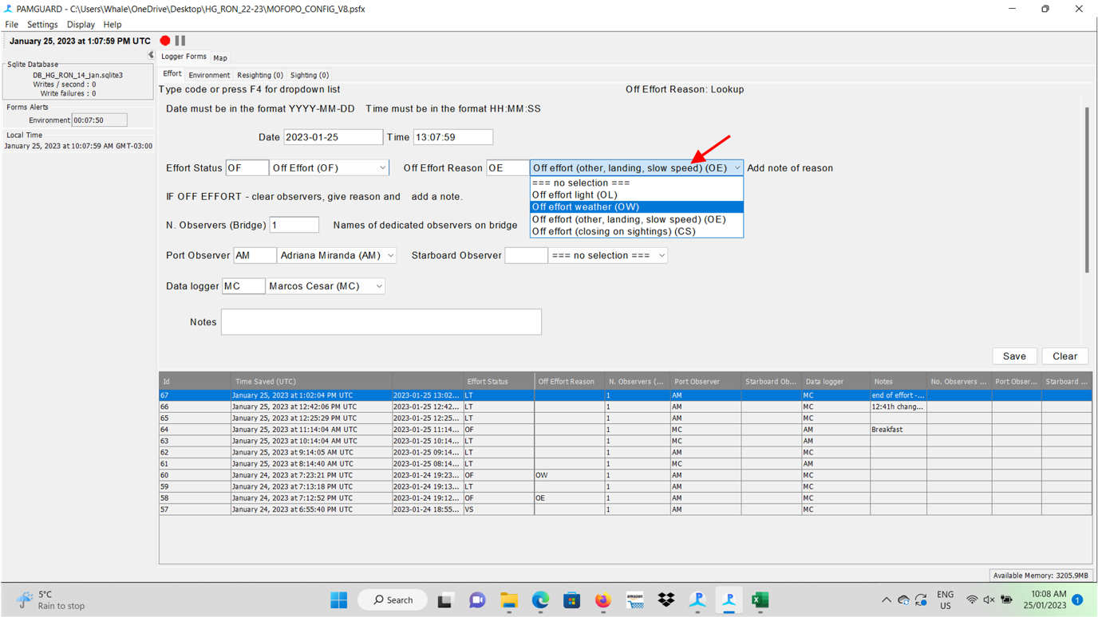

Make sure you save the form every time. This means from now were are doing this.

Figure 25. Saving PamGuard Effort form.

**Checking/editing effort data** – If you need to make any adjustment on previously inputted data, double click in the specific line at the bottom of this tab which represents the group of data that you are seeking for adjustment (red arrow indicating).

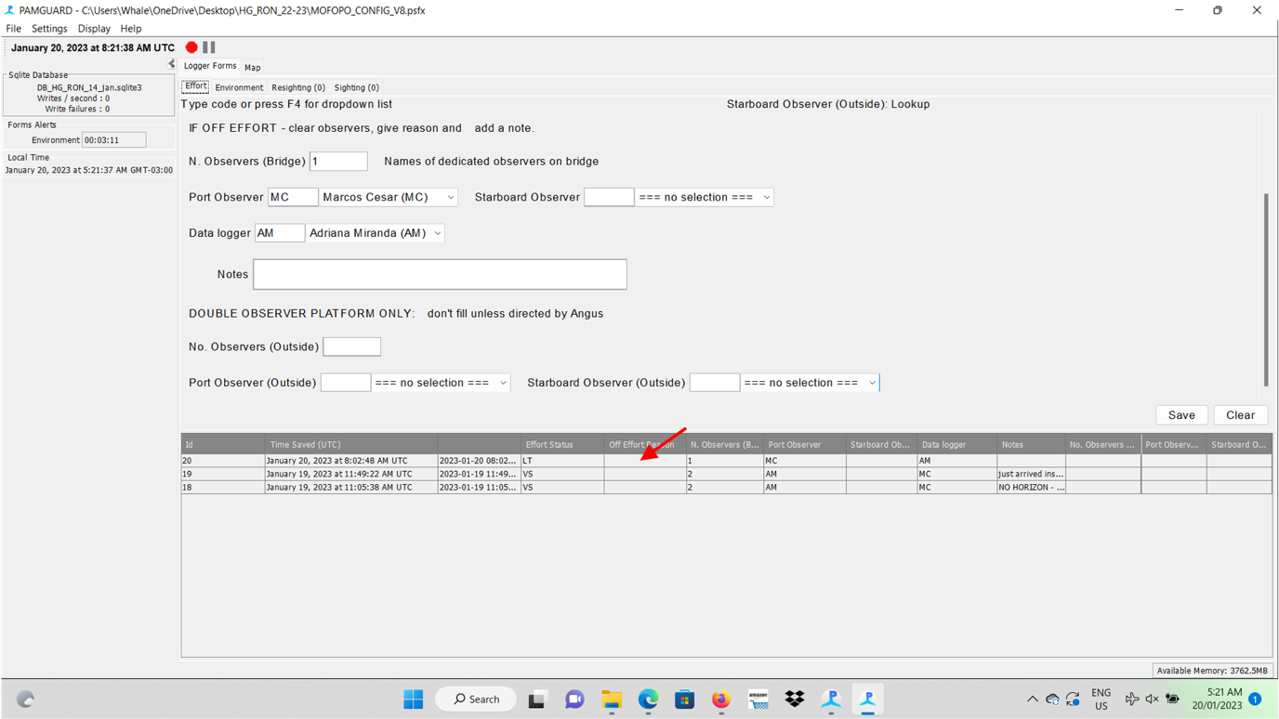

Figure 26. Editing data after it has been saved.

**Effort** – Edit your changes and save = click ok (red arrow indicating)

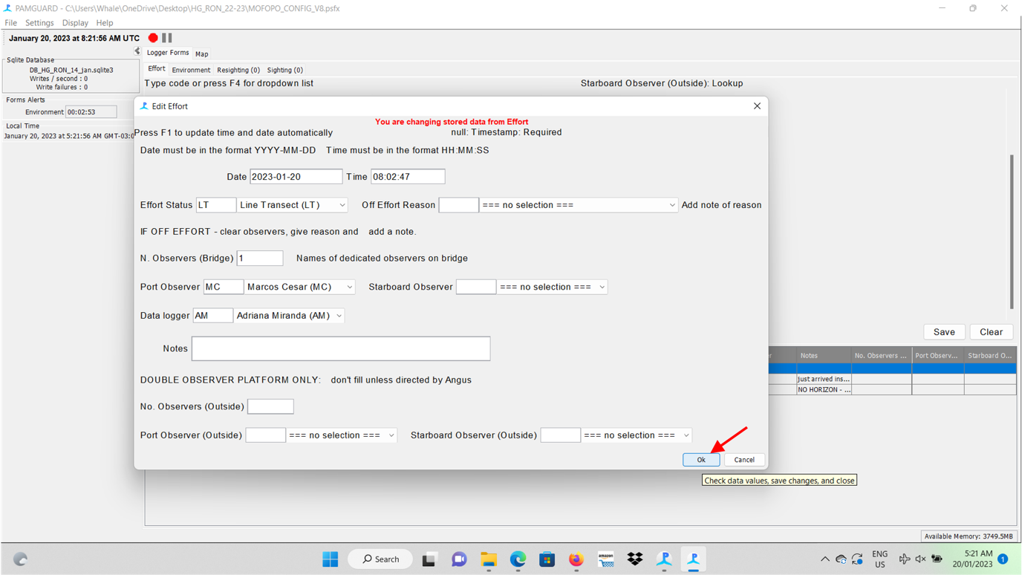

Figure 27. Editing data after it has been saved, part 2.

**Please, try to fill cautiously fill the gaps to avoid editing collected data.**

## Observing weather

**Environment data –** The **Environment** (weather) tab is the sole record of environmental conditions and data should be collected using a consistent methodology throughout the voyage/season. During **On Effort** periods, please record effort every 15 minutes (PamGuard will remind you).

Full search effort (i.e., **Effort = Line Transect**) is only conducted in acceptable weather conditions, defined below. Weather conditions are those observed in your observation quadrant (270->360/0) or (360/0->90)

Table 4. Defining appropriate weather conditions.

|  |
| --- |
| **Definition of acceptable weather conditions for Line-Transect survey.** |
| Acceptable weather conditions are defined as being able to see a strong minke whale blow (or other sighting cues) at a distance of at least 1.5 nautical miles (2.9kms), with true wind speed less than 25 knots (in the vicinity of the ice edge) and 20 knots (remote from the ice edge) and Beaufort Sea state 6 (inclusive) or less. Note that these are maximum limits and calmer conditions within these limits may still not be appropriate for ***Line Transect*** surveys |

These conditions are used as guidelines; in some circumstances, less severe conditions may still be inappropriate for search effort (i.e., **Effort = Line Transect**). If severe glare/precipitation/fog remain problematic **for several minutes**, observers may go **Off-Effort**. Precipitation can make bridge observations difficult, if the glass becomes too difficult to see through, go **Off-Effort** until conditions improve.

Take note:

* Of low light conditions as the steady reduction in light may not immediately obvious, but may hamper the observation process severely.
* That fog is likely to shift, often quite quickly, remain on the bridge and hope it clears.

During daylight periods, but with weather conditions too poor to survey, weather observations should continue every 1 hour. **Such *Off-effort* weather observations are incredibly valuable as they are used in planning future sighting surveys.** Take your time to make these recording, spend 5-10 minutes at least assessing the conditions.

When busy, weather is of lowest concern, focus on recording as much info as possible on sightings, and ensuring conditions remain good enough to the type of effort conducted.

Recording the weather seems simple enough but is a constant discussion refinement process. Having accurate weather observations is critical to the weighting of sightings/or lack of across the survey area to estimate abundance of species. Continue to refine and discuss weather observations to voyage progresses, and work to come to agreement where possible.

Additional information must be consulted, such as the Beaufort Sea state categories, ice and cloud coverages. The following print indicates the environment tab indicated by the red arrow. Most of the boxes to be filled can be find in the next figure. You’ll need to scroll down to reach all gaps to be filled.

**Environment: filling the gaps** – Complete all the information indicated below, except date and time as the software should automatically provide in UTC. You’ll find room to fill the following information: **Sightability**, **Sea state**, **Swell**, **Weather**, **Cloud cover**, **Visibility**, **Light Levels**, **Glare Intensity** and covered area, info on **Ice cover** and **type**, and a field to write **notes** only if necessary.

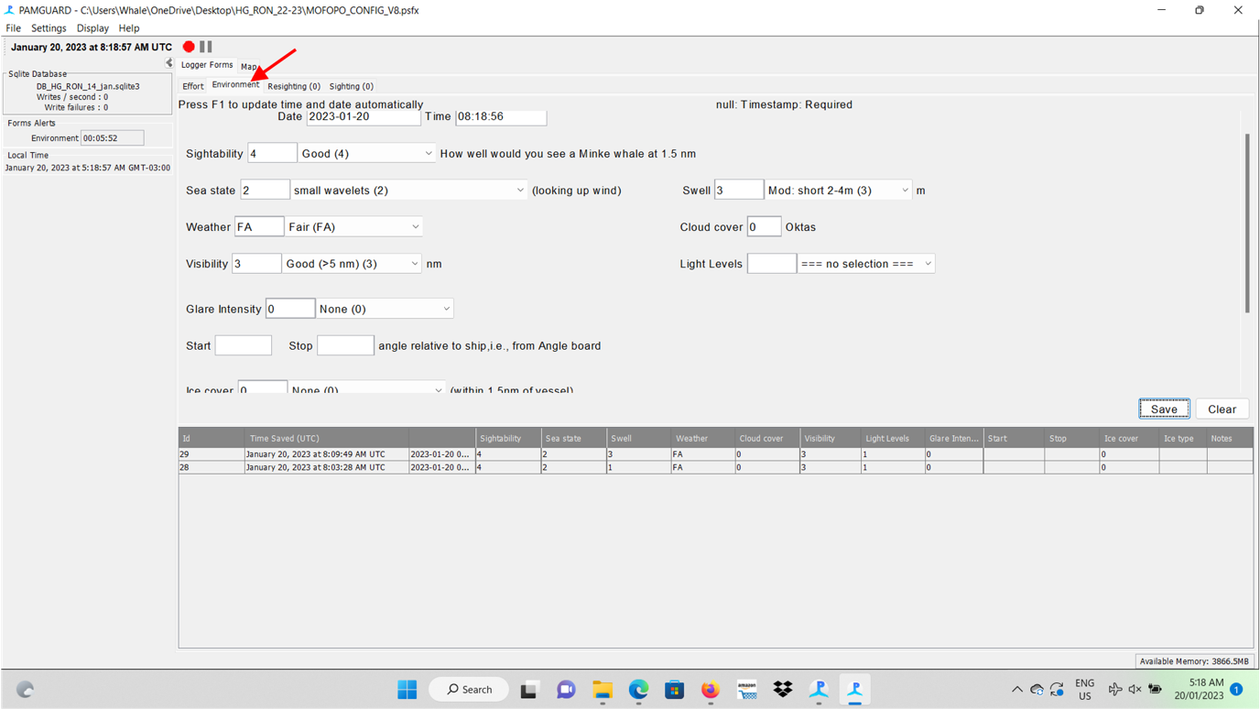

Figure 28. Environment tab

### Sightability

This value is the qualitative assessment of the sighting conditions, essentially answering the question, how well do you believe you are able to see a minke whale (blow or other sighting que) at 1.5 nautical miles. **This value is key, and is single value is often used to express all weather conditions in analysis**. 1 (very poor) – 5 (excellent).

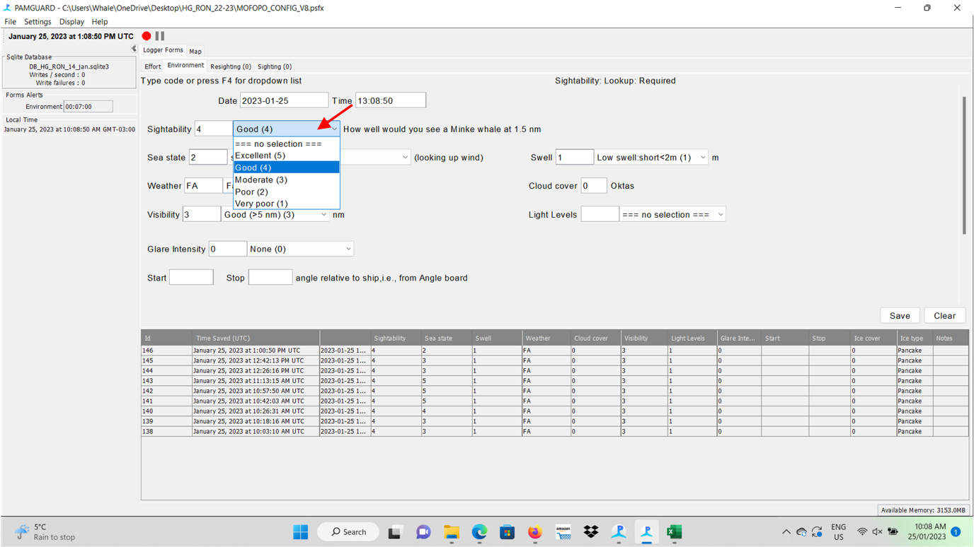

This guide is to help you put bounds on this critical but subjective metric. Sightability is a compound index, combining both sea state and meteorological condition, and its effect on light conditions. If **true wind is greater than 25 knots**, consider pausing effort (or going off effort), if its greater than 30 knots, go Off Effort.

WIND SPEED IS **TRUE WIND SPEED** MEASURED as a 2-5 minute average, not relative wind.

Table 5. Sightability scale

|  |  |  |
| --- | --- | --- |
| **Effort type** | **Sightability** |  |
| LT | Excellent (5) | Confident of seeing a strong minke whale[1] blow at 3000m or more of the vessel. Near perfect conditions and above. |
| LT | Good (4) | Confident of seeing a strong minke whale blow within 2000m of the vessel and potentially out to 3000 meters. Also requires a clear horizon with enough contrast to allow a blow to be detected at the horizon. |
| LT | Moderate (3) | Confident of seeing a strong minke whale blow within 1000 meters of the vessel and potentially out to 3000 meters. Any of these are considered moderate.   * true wind less than 25 knots, all other conditions being close to perfect, <0.5 meters swell, good light, etc. * true wind less than 22 knots, most other conditions being perfect & swell less than 1 meter. * true wind less than 20 knots   Note that even when the true wind is less than 20 knots, sightability could still be poor or very poor based on other conditions effecting the observers’ ability to see whales.  If the horizon is visible, reticule readings are possible, but visual contrast is poor for detecting blows, then sightability would be considered Moderate. |
| VS/OF | Poor (2) | not confident of seeing a strong minke whale blow within 1000 meters of the vessel |
| OF | Very Poor (1) | not confident of seeing a strong minke whale blow at any distance |

**Sea state** measured on the **Beaufort categories**. Use the ships TRUE wind reading (5-15 minute average knots) **mostly,** and notes in each category to guide you.

### Sea State and Swell

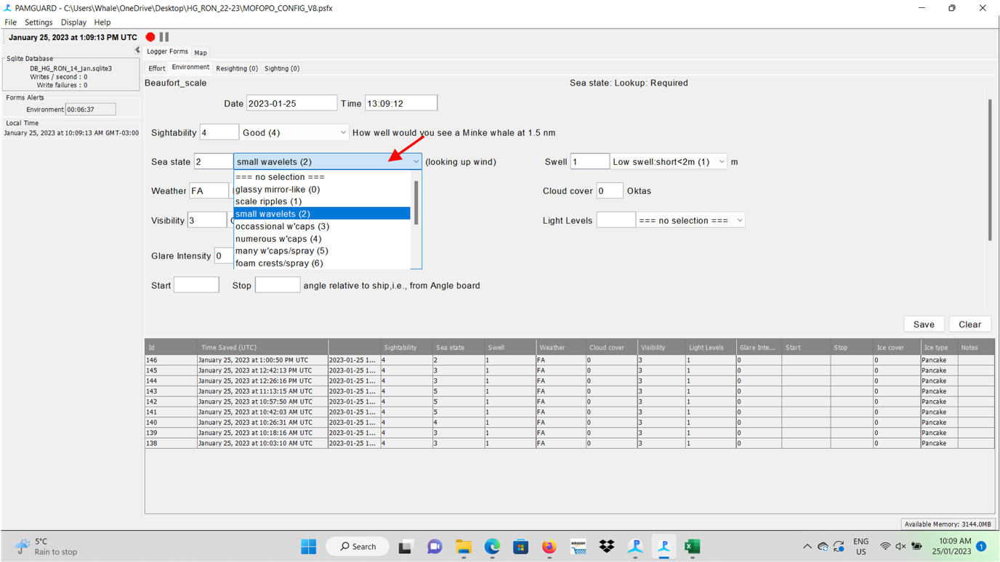

Figure 29. Sea state

Beside the sea state box, you’ll find the one related to **Swell**.

Options: No swell, Low swell short<2m, Low swell long <2m, Moderate swell short 2-4m, Moderate average swell 2-4m, Moderate long swell 2-4m, Heavy short swell>4m, Heavy average>4m, Heavy long>4m and Confused.

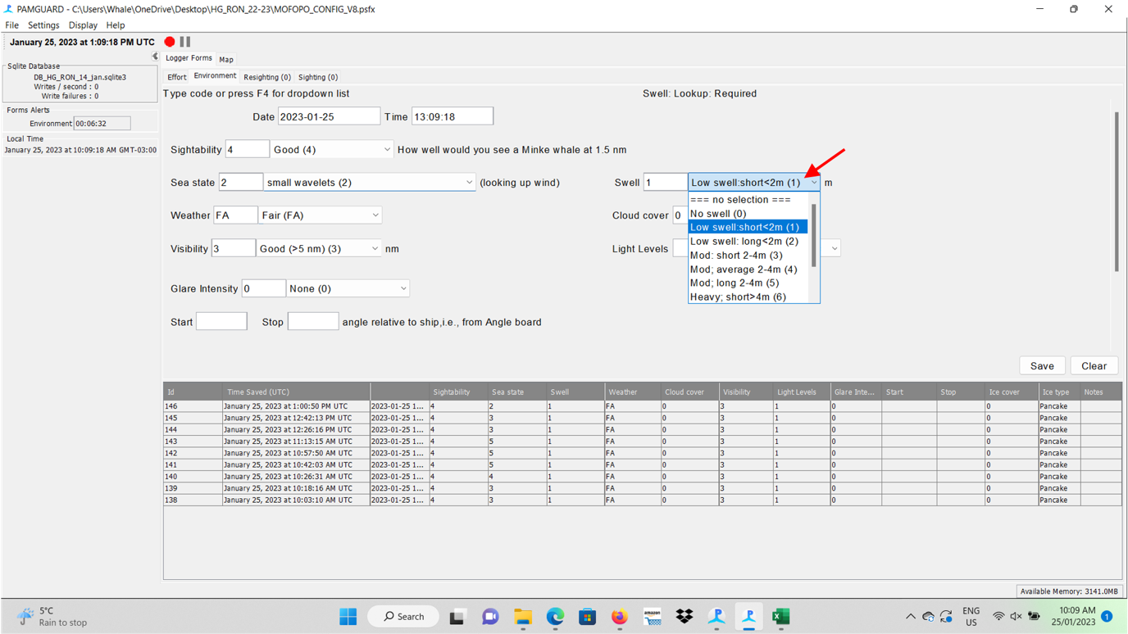

Figure 30. Swell

### Weather and cloud cover

The **Weather** box with the following options: no selection, Fair, Haze, Mist, Drizzle, Rain, Fog and Snow. Marking the dominant weather pattern is a priority. It’s important to note differences in precipitation between rain and hail. Sleet and snow. Particularly, as snow is less likely to obscure vision in the same way as rain will by moistening the windows.

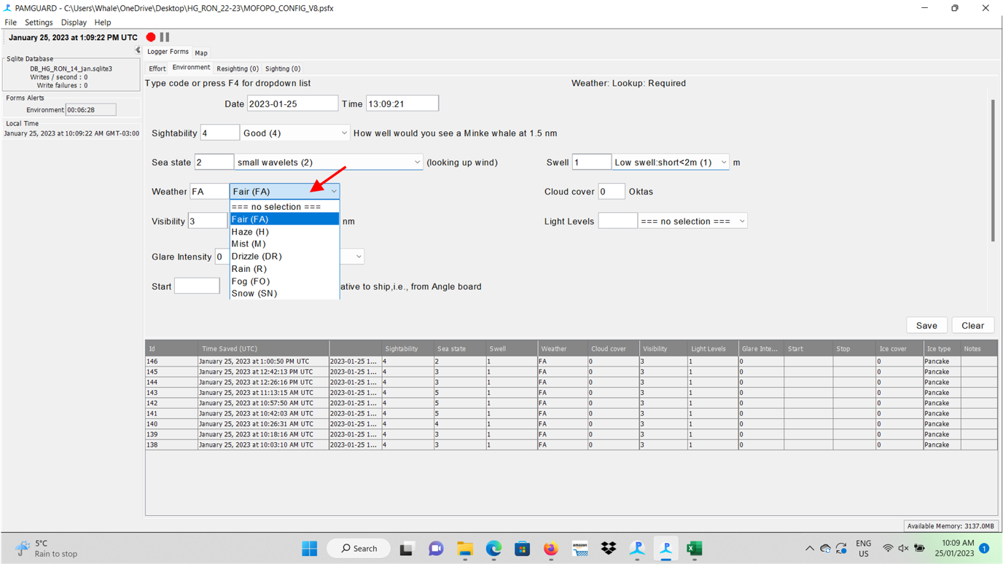

Figure 31. Weather

**Cloud cover** measured in oktas (0-8), across the whole sky.

### Visibility and light levels

**Often in the Southern Ocean, a false horizon is apparent, obscured by fog. If this is the case, visibility is not categorised as High. Take care with making distance measurement in these conditions as false horizons can cause inaccuracy. When viability is reduced, your assessment of sightability is still an assessment of the sighting conditions of the entire quadrat, not the reduced section (e.g., low visibility will mean low sight-ability).**

Consider the distance at which you can make a sighting of a minke whale (blow or other sighting cue). High (2-5 nm) visibility is for when the horizon is unobscured.

**Visibility**, with the following options: no selection, Fog (<1000m), Poor (1000m – 2 nm), Moderate (2-5 nm), and Good (> 5nm).

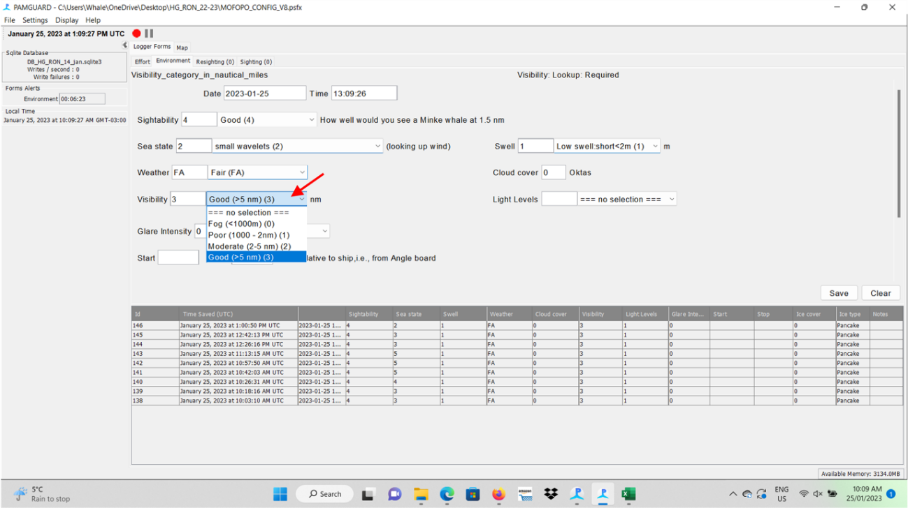

Figure 32. Visibility

**Light Levels**, with the following options: no selection, Good, Moderate and Poor.

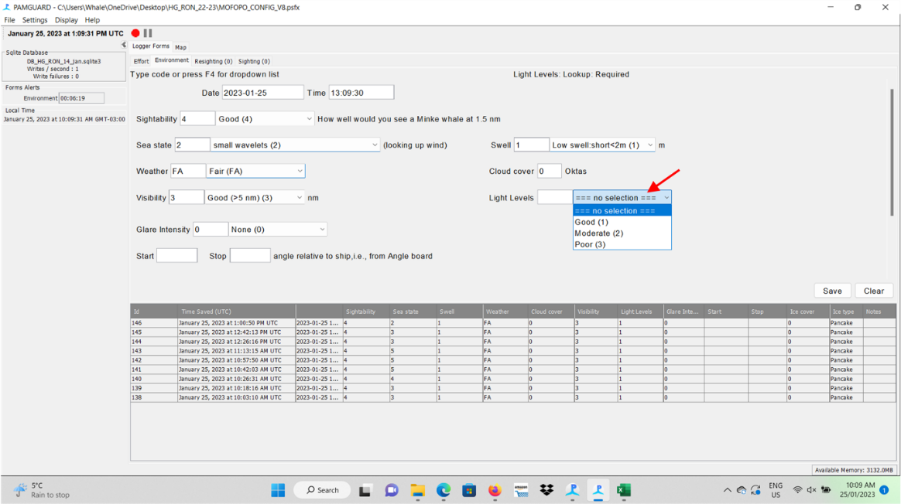

Figure 33. Light Levels

### Glare and Ice

If there is no glare on the surveyed area, no selection or None are the options. If there is glare on the surveyed area, you should choose between the Moderate and Severe classes depending on its intensity. After that, you need to fill the boxes presented just below. Use the angle board to measure glare angle, start to stop (e.g., start = 273, stop = 317)

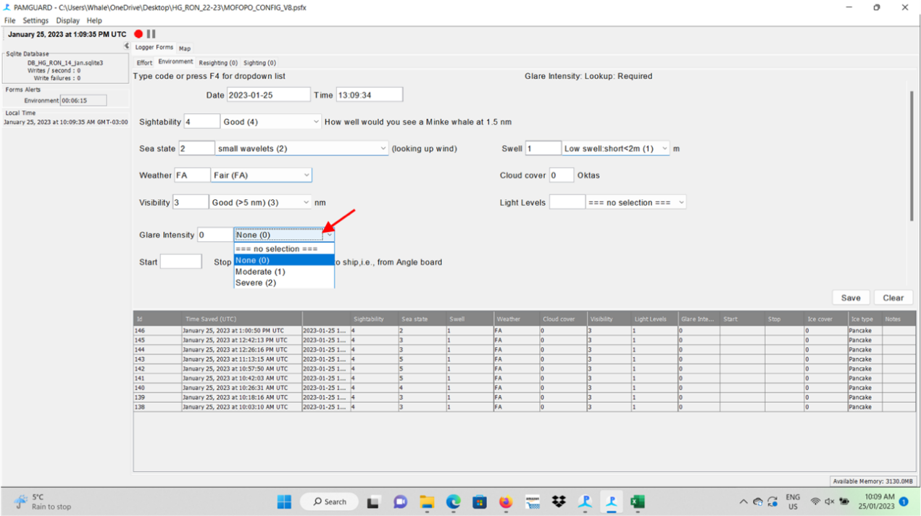

Figure 34. Glare

The final boxes are related to ice coverage and to the type of ice that may be on the track. The first boxes are related to the **Ice cover within 1.5 nm of the vessel** and presents the following categories: no selection, None, Few small bergy bits, Multiple bergy bits, Patches of 50% cover, 1/10 cover, 2/10 cover, and up to 10/10 cover.

Consider this the portion of the viewing quadrant 0->90˚ (ahead of obs platform through to a beam) and out to 1.5 nm (≈3kms) that is lost due to ice cover. Add notes to be explicit if possible – e.g., iceberg blocking xx degrees to xx degrees, approx. xx kms away.

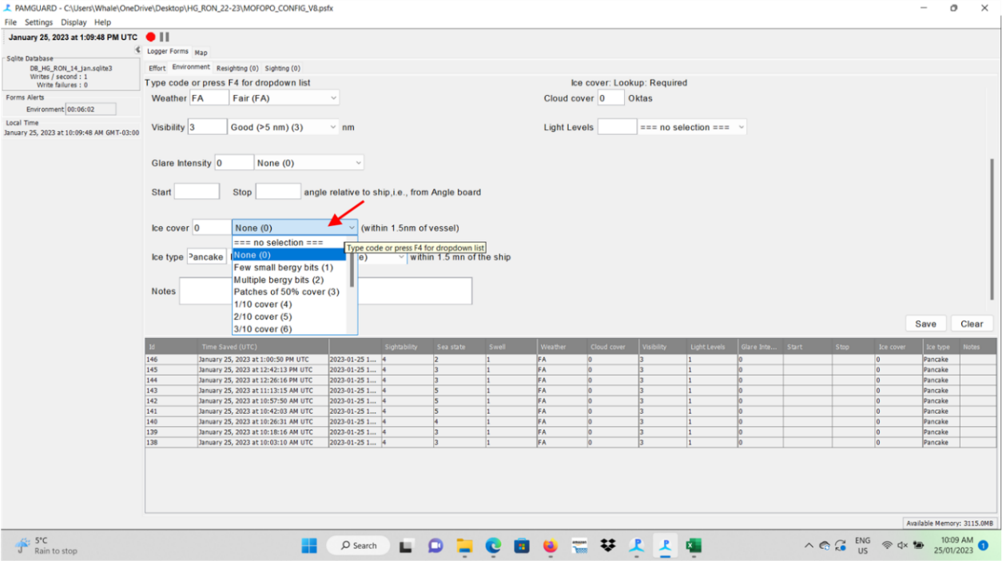

Figure 35. Ice Cover

**Ice type within 1.5 nm (2.9kms) of the ship** presents the following categories: no selection, 1st year, 2nd year, Bergs, Small newly formed, Broken pieces, Rounded floes 0.3-3m (pancake), Level pieces 20-100m (small floe), Level continuous100-500m (MedFloe), Level continuous 0.5-2km (BigFloe), Level continuous 2-10km (VastFloe), and Level continuous >10km (BigFloe). (not important to know the ice types)

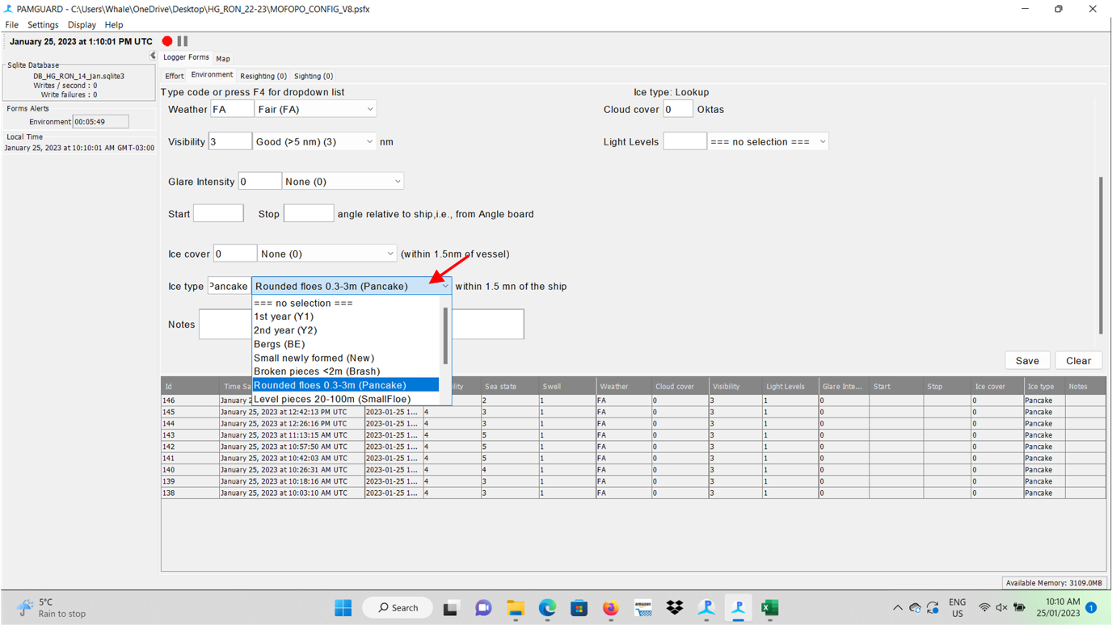

Figure 36. Ice type

### A few further notes on sighting marine mammals in different weather conditions.

Keep in mind when reporting weather conditions:

* TRUE wind speed is probably your best objective measure when determining effort type, and sightability.
* When conditions are calm, but perhaps with poor lights, marine mammals often breath more gently and are harder to see than what would be expected in what appears to be quite good sighting conditions.
* When there is strong wind, but flat seas (e.g., near ice/land), it can seem that sightings would be made easily, but be aware that strong winds disperse blows quickly and they can be easily missed. Over 25 knots (in the vicinity of the ice edge) or 20 knots (remote from the ice edge) and Beaufort sea state greater than 6 (inclusive), there is little point in observing.
* Be aware of your biases when previously experiencing consistent good or bad weather days, as they may influence your perception of the current weather conditions.
* When light is low, the weather can seem better than it is as white caps become harder to see, refer to wind speeds and note any bias.

## Ice Guide

Few bergy bits (bergs) Multiple bergy bits (bergs)

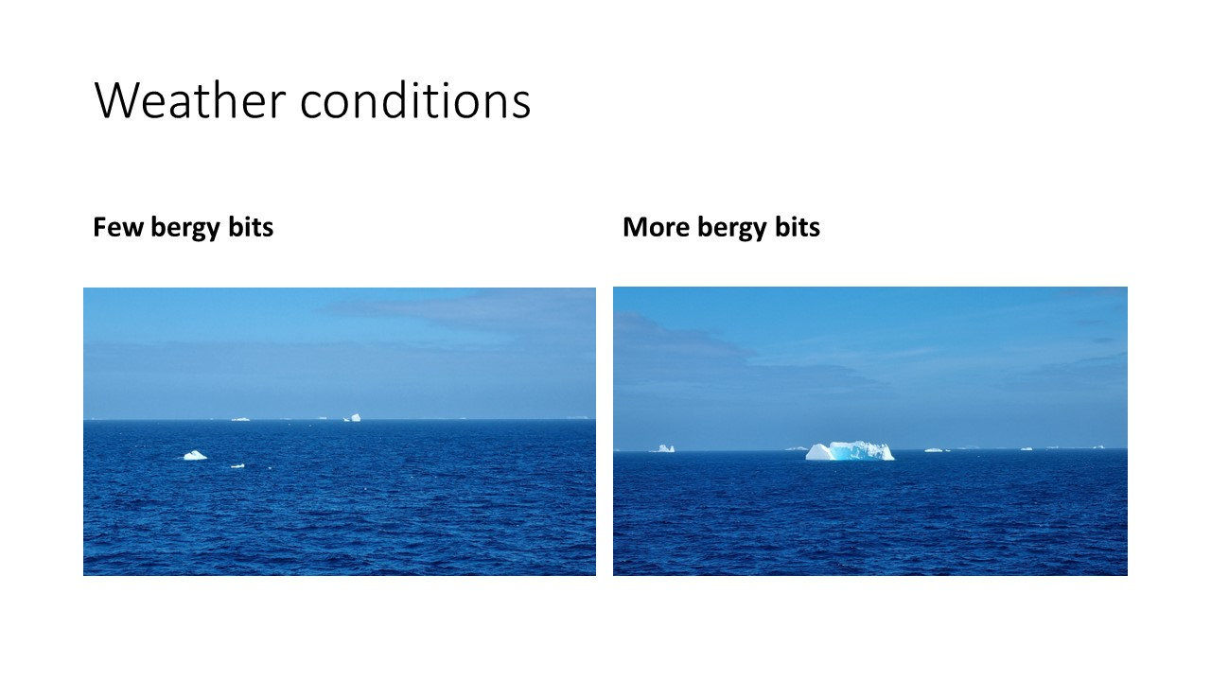

Grease Ice. Patches of 50% cover (bergs)

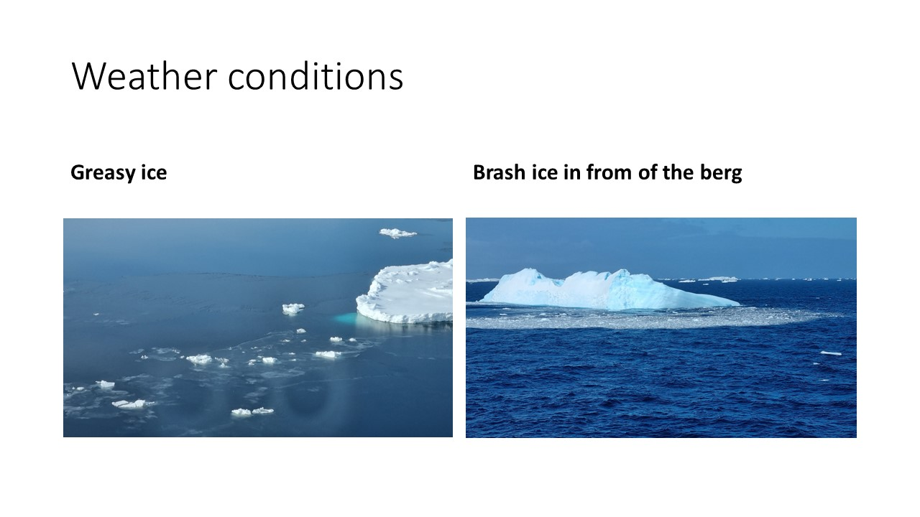2-4/10 ice cover. (pack ice)

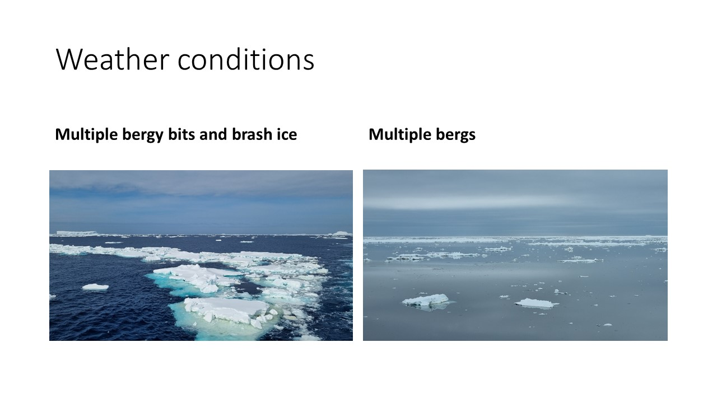

5/10 ice cover. (pack ice) 7/10 ice cover. (pack ice)

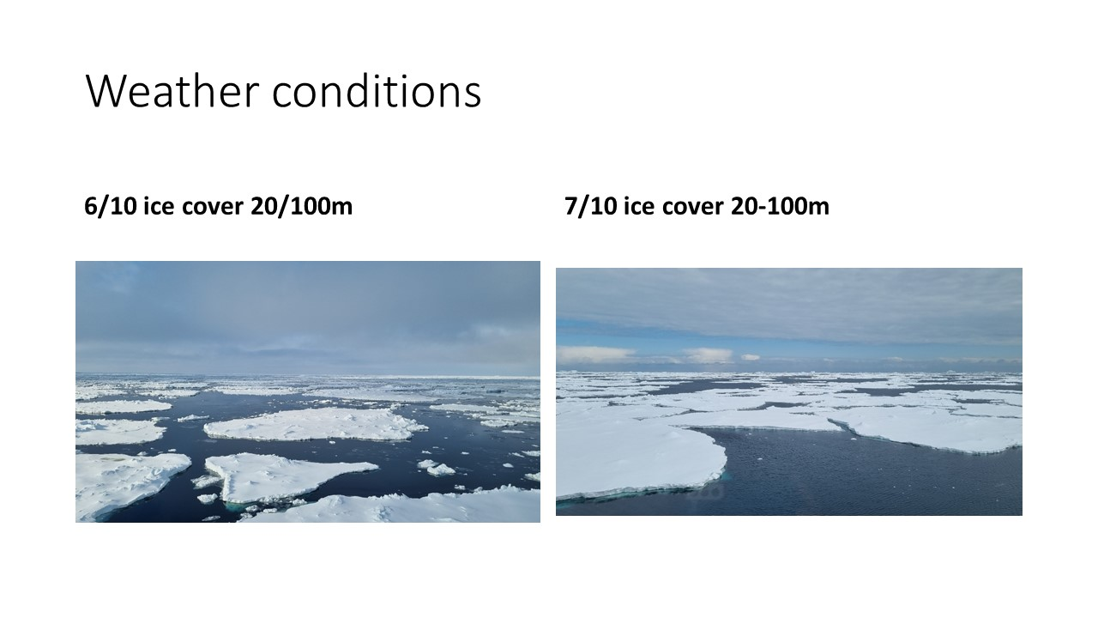

9/10 ice cover. (pack ice)

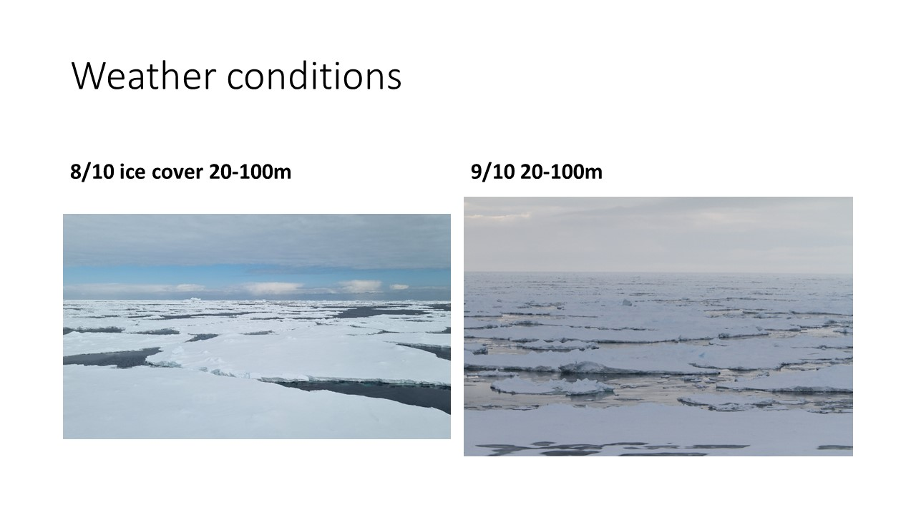

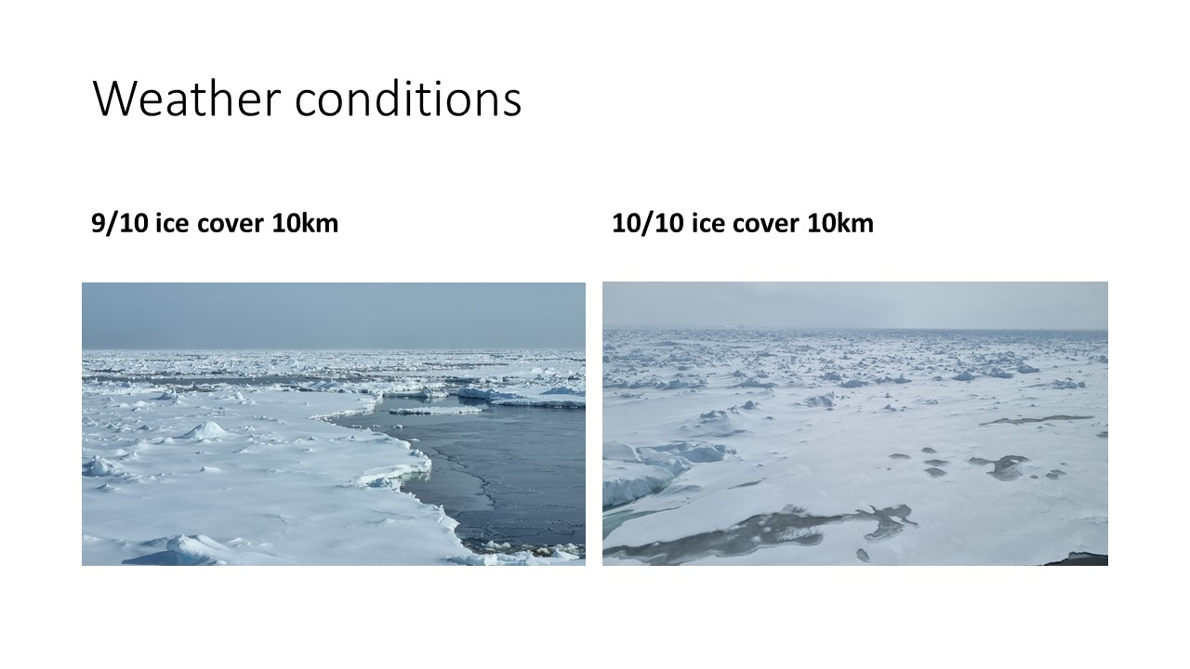

## Sighting data

### Making a sighting

When a sighting is made, the data logger opens a S**ightings** tab (by double click the **Sighting** tab (red arrow indicating)). This takes the time (which will be matched to the location in postprocessing).

The observer must **first record angle, reticule, sighting cue,** and relay this to the datalogger.

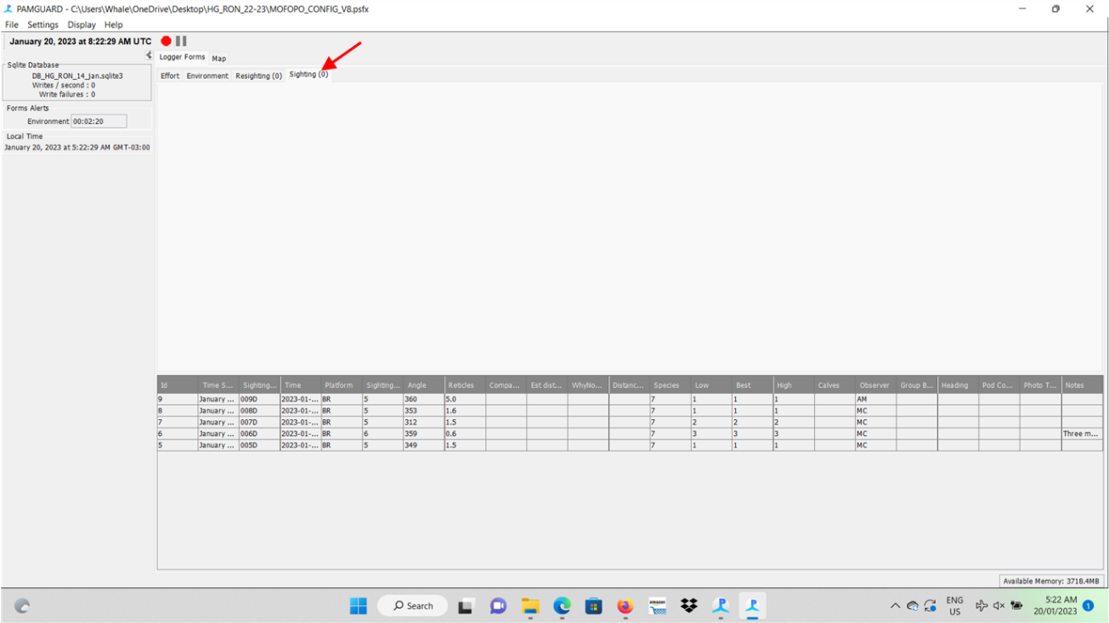

Figure 37. Sightings Form

### Entering Sightings data

The first 3 boxes are automatically filled by the software after double clicking on **Sighting** tab. The fourth one, just after Time, is related to the **Platform** of sighting (red arrow indicating).

The options are Bridge (BR) or Incidental (IS).

BR = within quadrant, effort – LT or VS,

IS = are outside quadrant, effort = OF, not observed by primary observer. (PLEASE PUT NOTE AS TO WHY)

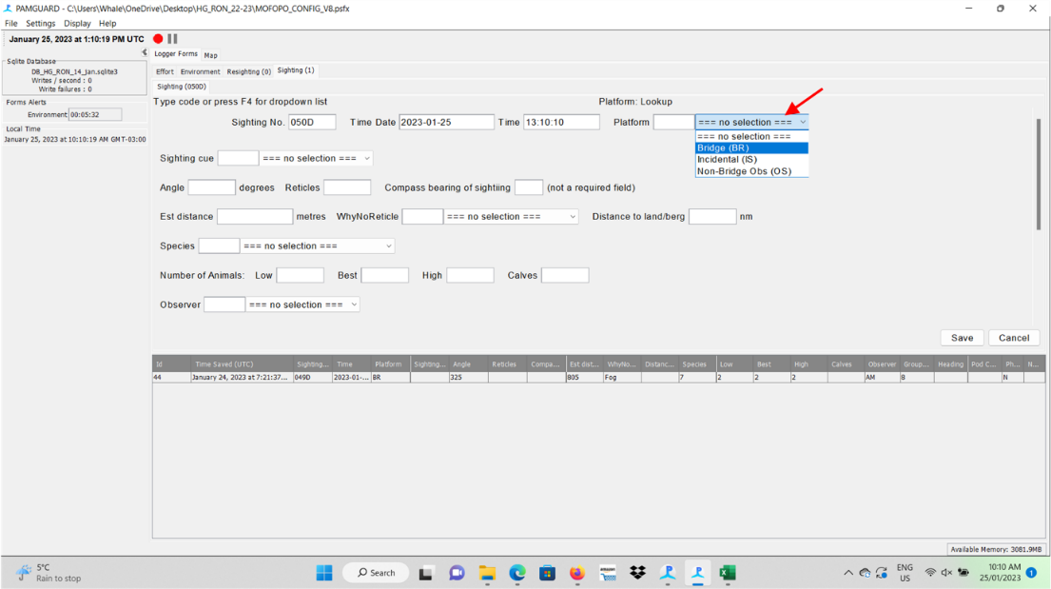

Figure 38. Entering Platform data.

The second line has just one box related to the **Sighting** **cue** that led you to detect a cetacean, and may vary from Body, to Splash, to Breach/jump, to Footprint, to Blow, to Flash, to Sea birds, to Other wildlife and to Sound.

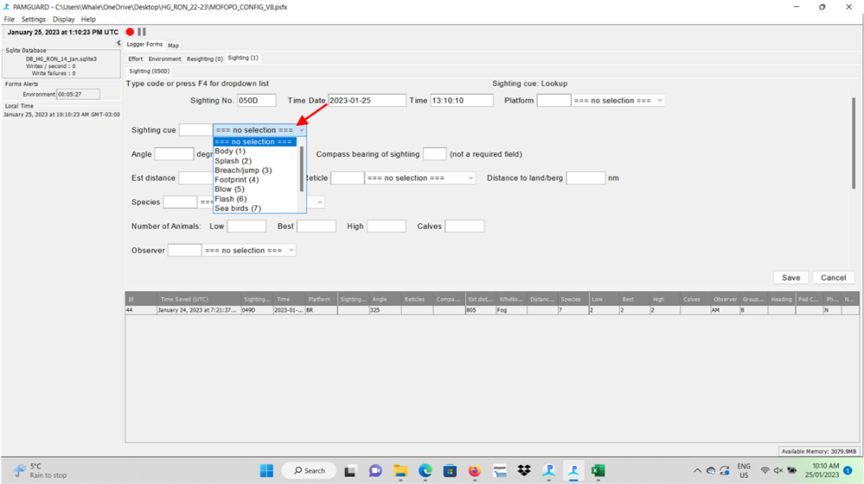

Figure 39. Sighting Cue

### Recording Angle

Recording angle(using the angle board) and distance (using binoculars) allows us to estimate the distance of the sighting from the vessel. This is critically important and should be priority when making observations.

Angle boards with pointers must be used for any angle measurements and reticle binoculars must be used for any distance measurements.

**Angle measurements are at 1° increments**. Use the pointer provided to line the sighting up with the correct angle.

* Angles are to be recorded to the 1 degree (please no ‘heaping’ at 5° or 10° intervals).
* Be aware of ‘edge effect’ the tendency to ‘include’ sightings just outside the observation quadrant. Be precise with your angle measurement, if the sighting one degree outside the quadrant, record it as such. – this has been a problem with the data in the past for some observers, and cant be fixed.



Figure 40. Angleboard

### Recording Distance

**Distance is measured in reticles, the number of reticles from the horizon to the sightings**. Hold the zero-reticle mark on the horizon/sighting (if possible) and measure down to the sighting (at the finest scale possible 0.1-10). The large lines are increments of 1 and the smaller lines are increments of 0.5.

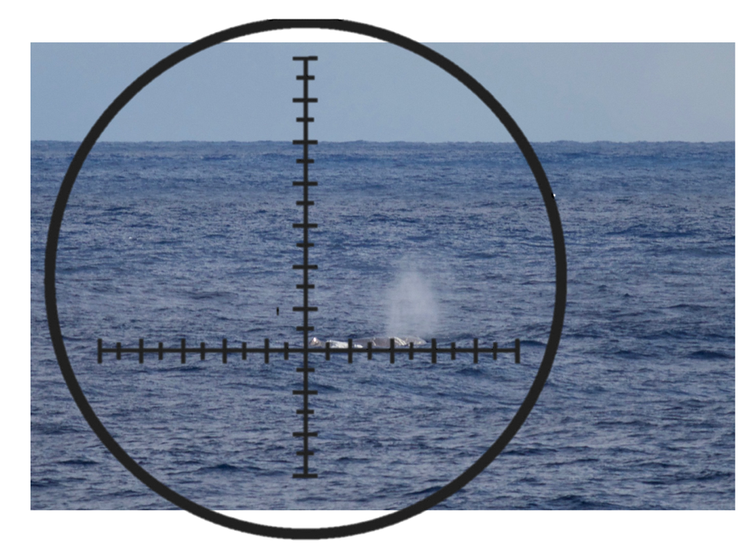

Figure 41. Measuring reticles, here reticles = 5.

**Note that you are making a measurement to the whale, not the blow, and that a blow lasting after the whale has dipped back below the surface is not an accurate indicator of distance.**

If you are unable to get an accurate reticle distance measurement, enter an estimated distance (in meters). When to enter meters and reticles has confused people in the past, so we have moved to noting the ‘type of distance’ estimation for clarity. If none of these categories suit the situation, add a note.

Table 6. Types of distance measurement.

|  |  |  |
| --- | --- | --- |
| **Types of distance** | **Circumstance** | **Data entered** |
| Accurate Reticle Distance | Confident of accurate reticle measurement. | Reticle only |
| Inaccurate Reticle Distance | Did capture reticle measurement of the whale, but not confident. e.g., only saw the whale briefly. | Reticle or Reticle and meters |
| No Horizon | Tried to capture reticle but lack of horizon made it difficult. | Reticle and/or meters. |
| Land/ice in the way | Tried to capture reticle but land/ice made it difficult. Try to estimate where the horizon would be, to the side of the sighting for example. (there is no perfect solution here).  Enter distance to land/ice if possible, see ships map/radar. | Reticle and/or meters. |
| Did not see in binos | Tried to capture reticles but failed. E.g., saw the blow only not the whale. | Reticle and/or meters |
| Too Close | Whale at close range (<500 meters) make and estimation of distance. | Meters only. |

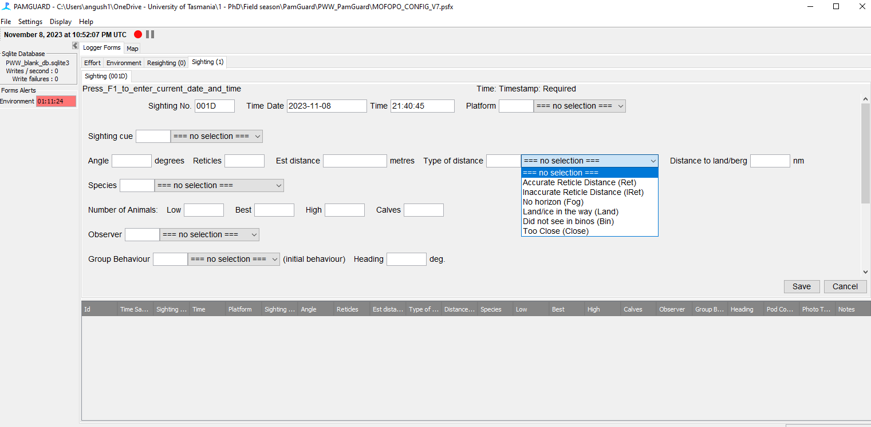

Figure 42. Type of distance

### Identification of species

Observers identify cetaceans to the level of species/stock when possible. Assignments are conservative, starting with the most general category that can be assigned with certainty, rather than a more specific classification. The school may be "mixed", containing more than a single sighting category.

Use the following guidelines for classification or identification:

* Positive identification of species is based on multiple clues and usually requires the clear observation of the whale's body. Occasionally, repeated observations of the shape of the blow, surfacing, and other behavioural patterns may also be sufficient.
* Probable identification (e.g., “like fin”) of species is based on multiple clues, which are nevertheless insufficient to be absolutely confident in identification. This usually occurs when blows are seen, the surfacing pattern is correct, but the whale's body cannot be seen or clearly seen. Sometimes in surveys, observers are asked to nominate how certain they are for species ID (something like definite, probable or possible). Here, however, we ask you to rate your species ID certainty in classifications for species, e.g., if you’re certain that’s an Antarctic blue whale, then call it that. You think it might be, but you’re not sure, maybe call it ‘like’ Antarctic blue whale, etc.

Note, the general categories, will include/exclude certain species, and this should be considered to allow the assignment of the most refined categories for a given set of sighting glues.

Unidentified marine mammal – includes everything below and pinnipeds

Unidentified whale – excludes dolphins, but not pilot or killer whales.

Unidentified dolphin – includes all dolphin species.

Unidentified pinniped

Unidentified large whale – most baleen and sperm whales, not mikes.

Unidentified small whale – includes minkes, killer, pilot, beaked, and bottle-nosed whales

Unidentified large baleen whale – includes all baleen whales except Minkes - excludes sperm whales.

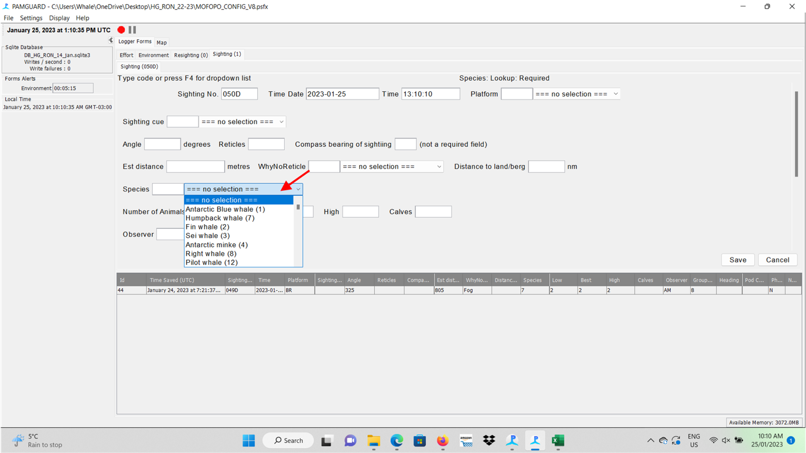

Figure 43. Selecting Species

Here typing the first letter of the species will auto select, pressing the same letter will get you the next species with that letter. Eg. Press “L” once will get you ‘like blue’ press again will get you ‘like fin’.

Just below the species id, you need to insert the estimated or the precise **Number of** individuals/animals, with the recommendation to provide de minimum (low) and maximum (high) estimates, the best number, and, whenever possible, insert the number of detected calves.

The next line of boxes is related to the observed Group Behaviour. The following options are available: Slow travel, Fast travel, Milling, Resting, Feeding, Social, Undetermined, Not recorded, and Surface activity.

Killer whales should be reported to type where possible.

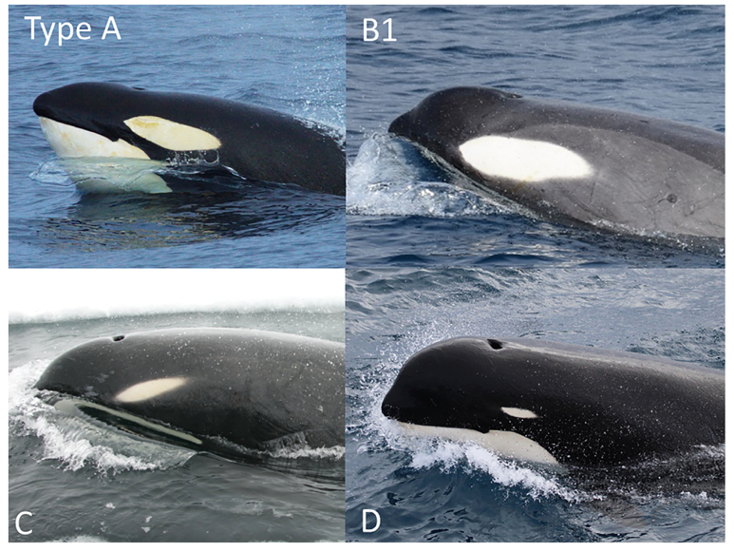

### Aggregations

You are likely to come across large aggregations of whales (>20 individuals, up to more than 100) generally in several small groups. These can be quite overwhelming.

* These sightings always come out of nowhere, and you are not ready.
* **Take your time with these sightings working through each group individually.**
* Do your best to get as many details as you can, then pass the sighting to the datalogger if possible ofr further details (species id behaviour etc)
* Its likely the ship change course to approach these sightings, when is does, go **Off effort**.
* All new sightings when you go **Off effort** are **IS – Incidental**.
* You can still add details to sightings from when you were on effort (i.e., BR-Bridge sightings) as you approach. But due to the movement of animals, and the change of direction of the vessel, there will be a point where clarity between sightings will be difficult.
* Start with the closest ones first.
* Do your best, it’s difficult.

### What is a group?

The approach used in distinguishing between separate sightings and subgroups of the same sighting is to enter what initially appear to be separate groups as different sightings. As the sighting progresses, if the groups can no longer be distinguished and none appear to have left the area, the putative sightings are merged into one by deleting (‘clearing’) the second sighting-event.

On the PamGuard Sighting form you can record data about ‘pod compaction’, how close or dispersed members of a group are. This is not critical data to capture (the form can be saved without it), however if time allows, please assess, and record this information.

For some species such as long-diving whales, determining whether a surfacing animal has already been detected and assigned a sighting number or is a new sighting can be difficult. New sightings are assigned only when there is no doubt that the mammal or group of mammals has not already been assigned a sighting number. If there is any doubt, the animal(s) in question are considered a part of the already entered sighting.

### Determination of group size

Observers will make three estimates of abundance for each school, “low”, “best” and “high”. The high and low estimates define the range within whose limits the observer is confident the school’s abundance falls. In rare cases, only a low estimate is possible.

Methods of estimating the number of individuals in a school vary, from direct counts for a small school, to counting groups estimated to comprise some number of individuals as a unit (i.e. “groups of ten”), to making a single estimate for an entire school seen at a distance. Take your time and watch a group for a moment as it may take a little while for animals to surface; be mindful, however, that if animals are feeding at depth, it may not be worthwhile to spend too much time watching for them to surface again.

### When Busy

Although we want to standardize the observation processes as much as possible, at times the sighting field will become busy and may overwhelm the observer, and the observation process can begin to break down. When this happens, the observer must continue to make observations (focusing on the front half of the observation field 45˚ and the closest animals first), but can direct the data logger to complete sightings if possible. For example, the observer makes the observation and records (at minimum) the angle and reticle and directs the logger to complete this sighting. The logger records extra sightings as incidentals if missed by the observers (passes 90˚ to the beam).

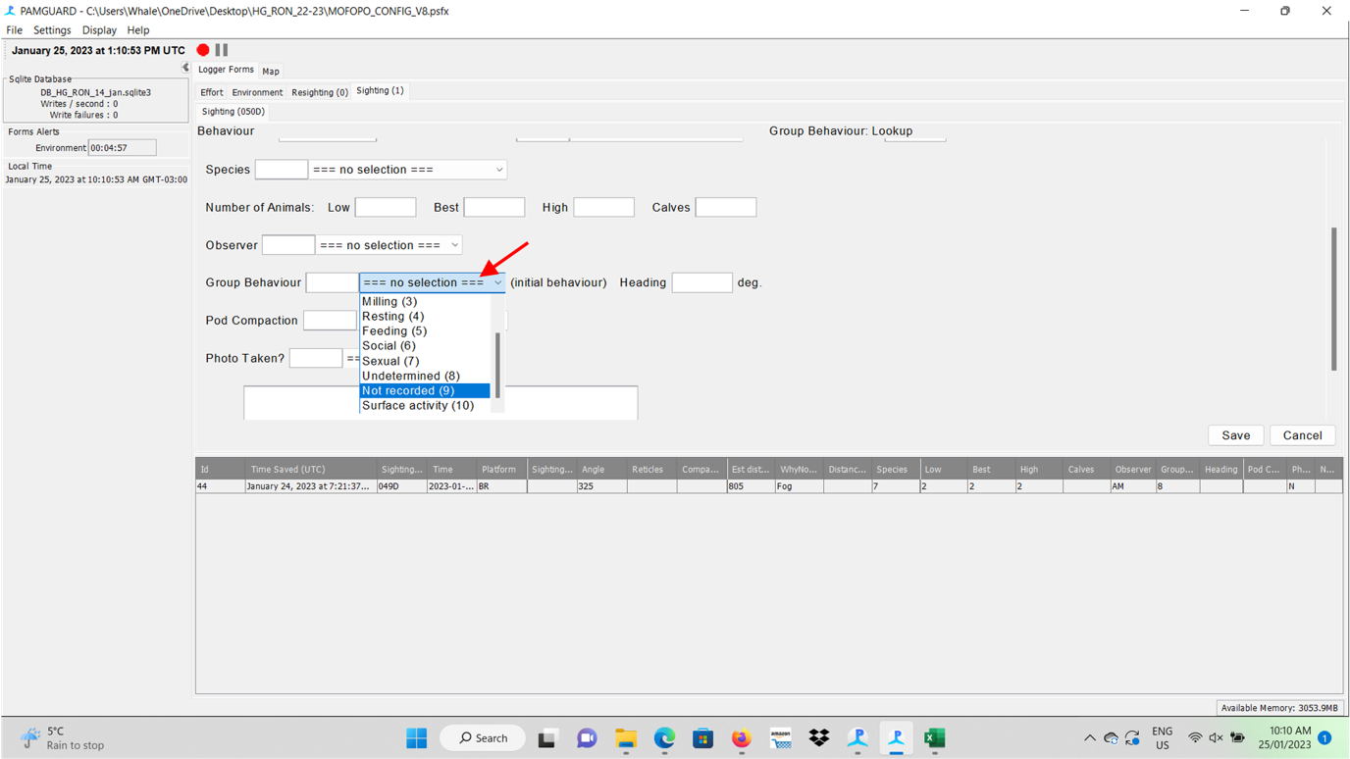

Figure 44. Group Behaviour

Try and have a minimum of two reasons why you think they are feeding, fluke up is not quite enough, fluke plus birds, or many powerful blows followed by flukes. Except for when it’s obvious, e.g., lung feeding at the surface, surface defecation. Miling is when animal/s change direction during surfacing/s. Resting is when they seem to be barely moving at all. Slow travel is quite common, when there is a persistent heading (space for heading to be noted).

Then you’ll find the box on **Pod Compaction**, with the following options: no selection, Undetermined, Most< 5 body lengths (BL) of other, All< 5BL of other, Dispersed >1nm, Dispersed >3nm.

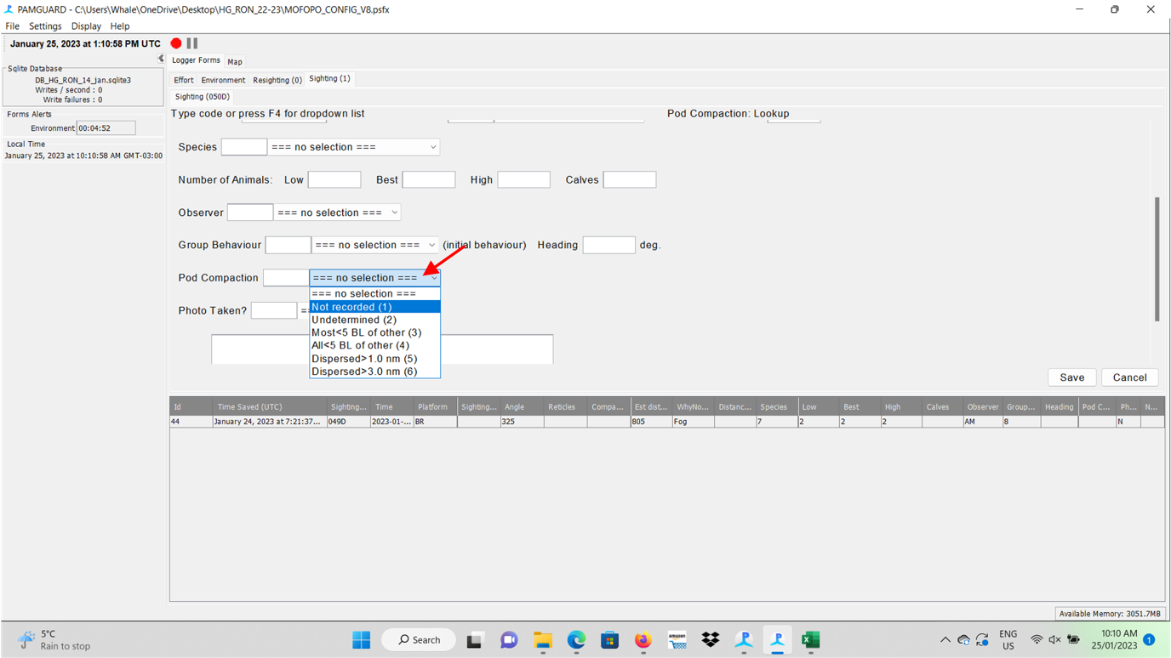

Figure 45. Pod compaction

Then you have the box to check if **Photos** were **taken**, with a simple and direct question of yes or no. Please, be aware on date and UTM time in the settings of your camera to match with this sighting data.

Finally, you’ll find room to insert any important **observation/note** about the sighting.

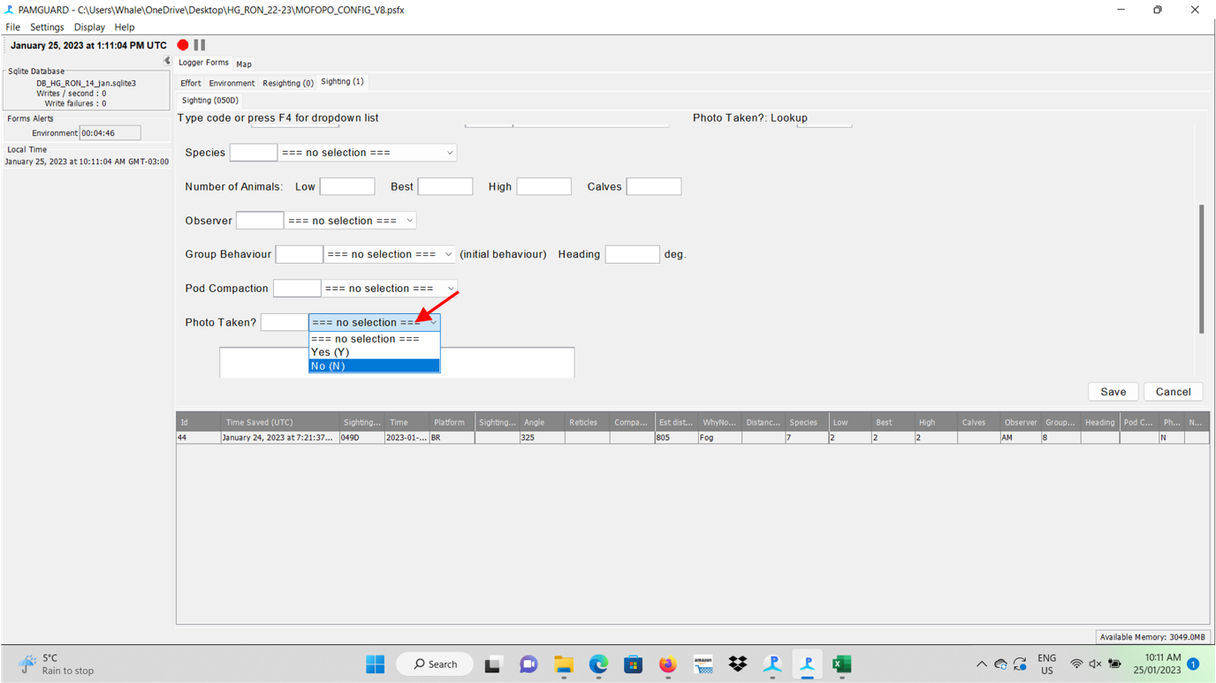

Figure 46. Photos Taken

After filling these gaps, you should **Save** the gathered/inserted data. Automatically, this sighting will receive a code and will show up in the list just below the tab on sighting.

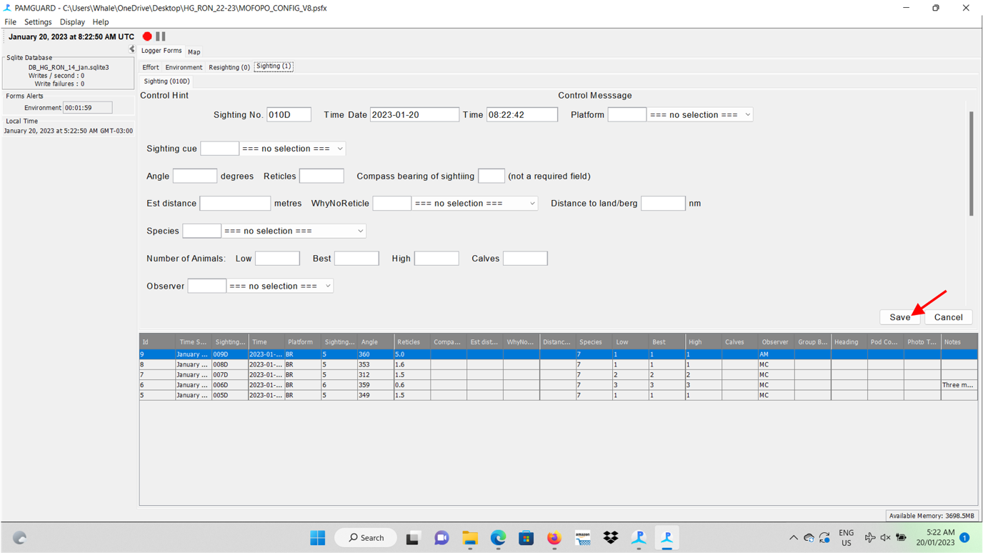

Figure 47. Saving the Sighting form

**Checking/editing sighting data** – If you need change or check any information on any recorded sighting, double click in the specific sighting line to be found below the data tabs, check the data or edit what is needed, and click ok if you want save the changes or cancel if you just wanted to view the data. The software will show only the recent ones, switching the group of sightings as more data is integrated to the databank along the survey.

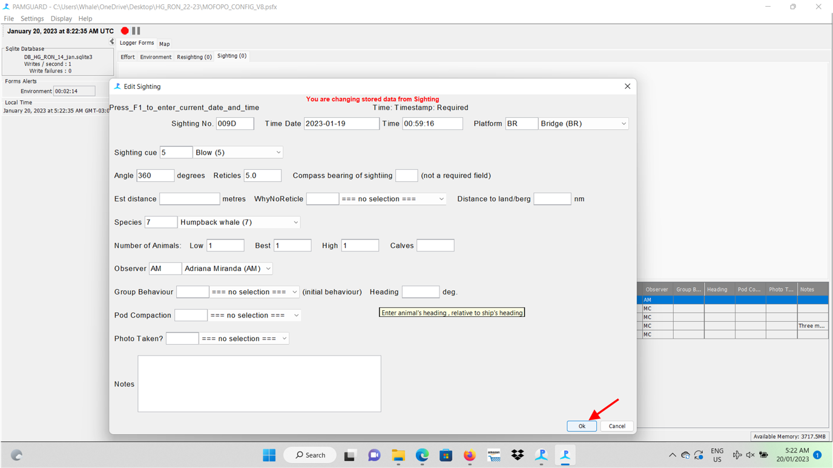

Figure 48. Editing past sightings

**It is recommendable to fill the gaps patiently to avoid further edits.**

### Marine debris

If you detect any marine debris during observation, please record this as you would a sighting. Species = Marine Debris. If possible, make several resighting (in the resighting form) as it moves through the sighting field. This will allow us to assess the density of marine debris in the Southern Ocean, as well as detecting observational errors and change over time.

## Resighting data

Used when an animal moves from outside the observation quadrant (IS - incidental sighting) to inside (BR – bridge sighting). This gives us a way to track the impact of animal movement of the observation process. Also used for sightings of Marine Debris, resighting of Marine Debris are interesting because they don’t move (as whales do).

Generally, its best to just add details to the original sighting as it passes through the observation field.

The **Resighting** form is almost identical to the **Sighting** form, except that it asks for a sighting number to be entered (the number allocated to the original sighting). The observer recording the resight must also relay to the data logger how confident (definite, probable or possible) they are that the sighting is actually a ‘resight’ and not a new sighting. If observers are confident it is a resight, there is less need to record all details on the sighting (such as species, group size etc.), as long as these are similar to the original sighting.

You open the **Resighting** tab where most of the **Sighting data** are presented. You should fill the **Platform** in the first line**,** as well as the **number of the Sighting** related to this resighting.

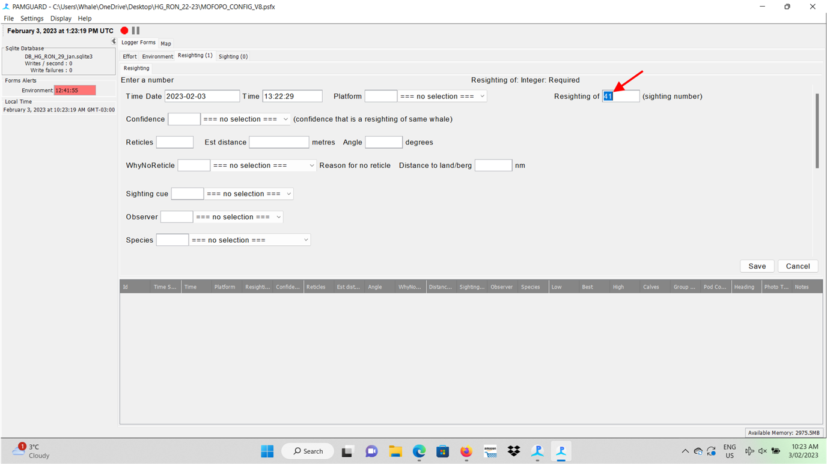

Figure 49. Resighting form, matching to the sighting number

Then your must fill the blank on the **Confidence** of the resighting, with the following options: no selection, Definite, Probable, and Possibly.

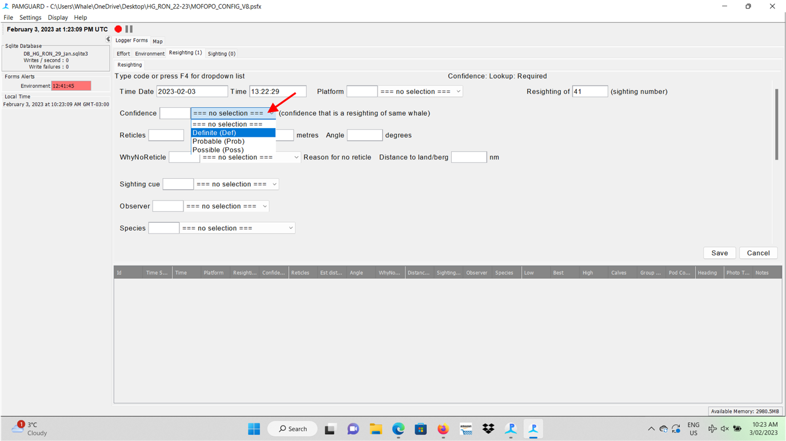

Figure 50. Resighting confidence

# TIPS TO OPTIMISE THE DATA COLLECTION AT THE BRIDGE

On the bridge where researchers must be respectful on the environment and the Captain and crew. Their rules must be followed. It is important to meet the science coordinator in charge of science duties on the expedition team, and politely ask them to introduce yourselves to the captain and/or his crew. In this introductory meeting, you may share the main duties related to your tasks and possibly the captain will establish the way things work in the very best way. Use “PWW_2_Observer Team_Host Company Expectations” to guide you if needed.

Different ships may have different rules. Even different captains on the same ship may have different rules. Another important tip is addressed the ones who will stay on board in 2 or more expeditions. There is a possibility of switching captains between expeditions, as well as crew members. Thus, it is recommended to restart connections in the next expeditions.

How to be prepared to the next working day? If you are starting observations at 5am, you probably won’t find food for a “morning meal”. It is strongly recommended that you get prepared in the day before your working days. You may take fruits from the breakfast to your room or even ask for the dinning staff for fruits. Usually, you may find the basic items to prepare coffee and/or tea in your cabin. Many ships have small fridges in most cabins. You may take fruits served in breakfast inside a Tupperware and keep inside your fridge.

Keep in contact with the expedition leader or the chief scientist. They will inform of daily plans beforehand. However, keep in your mind that polar regions are areas where the weather and sea conditions may change in minutes. Be prepared to last minute change of plans!

You can sometimes join the expedition team briefing. These meetings usually share all details on next day activities and guest scientists. Also, probably as weather forecast. If you can’t make it, see if you can get the program via WhatsApp, or from the bridge crew. But try not to request too much, and exist in the background.

True wind readout is usually listed somewhere, use this rather than asking repeatedly. As well as GPS, depth etc.

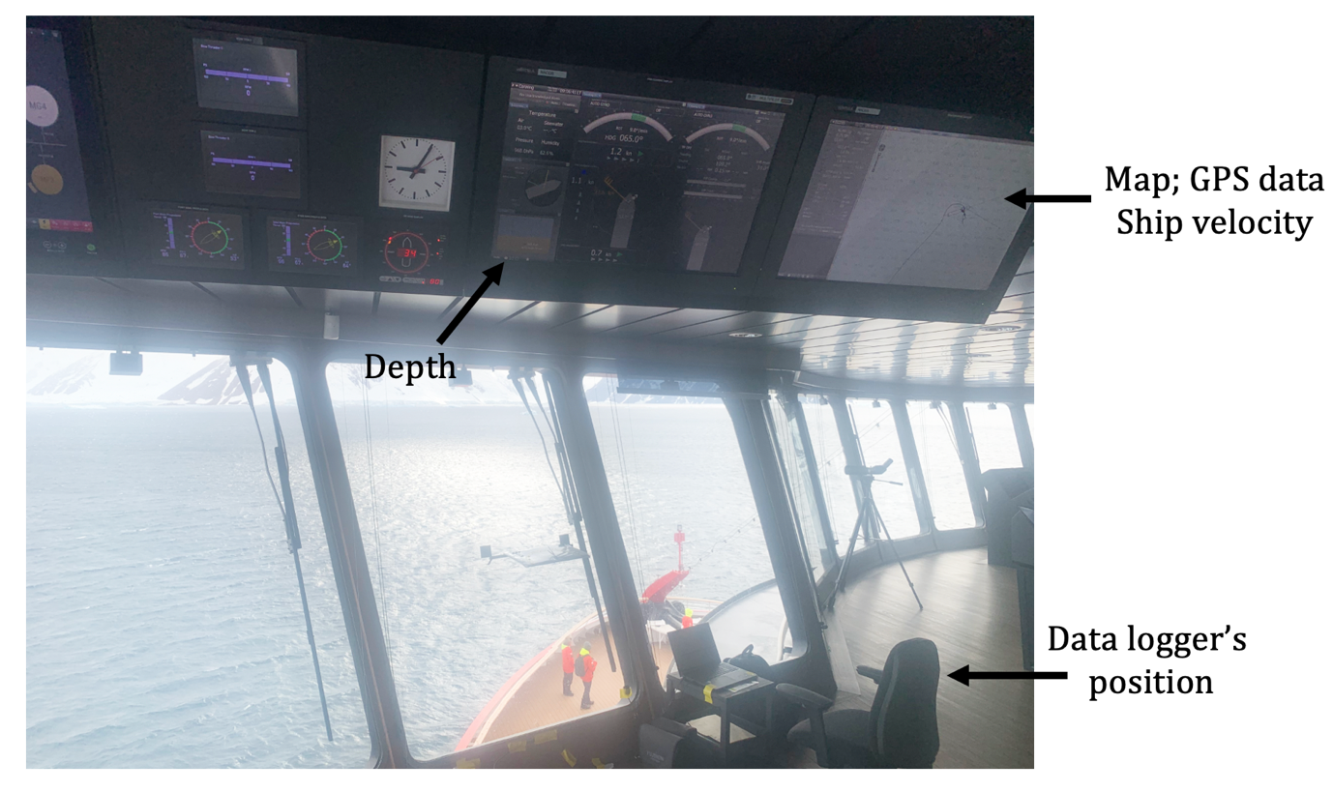

Figure 51. Readout of ship information, true wind, GPS etc.

Bathrooms, sometimes there is a restroom that may be used by non-crew members, and sometimes you’ll need to use a bathroom out of the Bridge based on the captain’s rules. Also, if it is allowed by the crew (please ask!), sometimes you may take to the Bridge something to eat/drink between meals (e.g. water, cereal bar, chocolate, fruits). You may take these items in a backpack, added to several tools that you may need when in DS, like sunglasses, a warmer vest, lipstick/sunscreen, and a professional camera. Depending on the daily temperature, air conditioning at the Bridge may turn it into a colder place to work for hours; so, always think on layers.

If it is possible, as soon as you go on board, try to check where the research equipment is placed (e.g. in a pelican case or already set up by a previous team). If everything is set, just try to check if the software and GPS are normally working. If you need to set up the equipment, try to do this before facing rough seas, if it is possible. It will give you plenty of time to set up everything in better sea state conditions, as well as to test the whole set of equipment (software, GPS, getting used with the binoculars and angle board), and get used to the Bridge panels.

The crew and the expedition team are mainly focussing on the guests’ happiness. As guest scientists, there are activities that you may get enrolled, and others you may not – or your should pay extra money as guests usually do. It is deemed important to balance your energy! Polar areas usually attracts all eyes, hearts and souls, and if you do not balance your energy in the 2 first weeks, probably you’ll feel tired soon and it may influence on DS data collection. Observers should stay focussed at the Bridge, scanning areas with binos, rotating with data loggers who are also paying attention on the route and weather an sea conditions which changes pretty fast. It is a time and energy consuming task! Thus, it is really important to get organized 1-2 days earlier to programme your shifts, letting enough time to rest your body and mind.

GOOD LUCK, YOU ARE GOING TO HAVE A GREAT TIME!

1.